urriciai h'UDiication o**t alua—A**n inLernauunai Abbuuiduun ui ouuuuuy n **uic^diui iqio**



New Lock Lube  
Marks Products  
and More!

./

PLUS!

Important1 How You Can Help Hurricane Suruiuors

|nfQ[t|||c|£jQn ^ Dominion Remouable Core

f Secondary Careers for Locksmiths  
paCJGS The History of The HLOR Open

32 34 ^ Golf Tournament

|®l,i On the Road with the RLOR Board

***************SCH 3-DIGIT 303 Brack H. Camp CML PO Box 47070 Atlanta GA 30362-0070

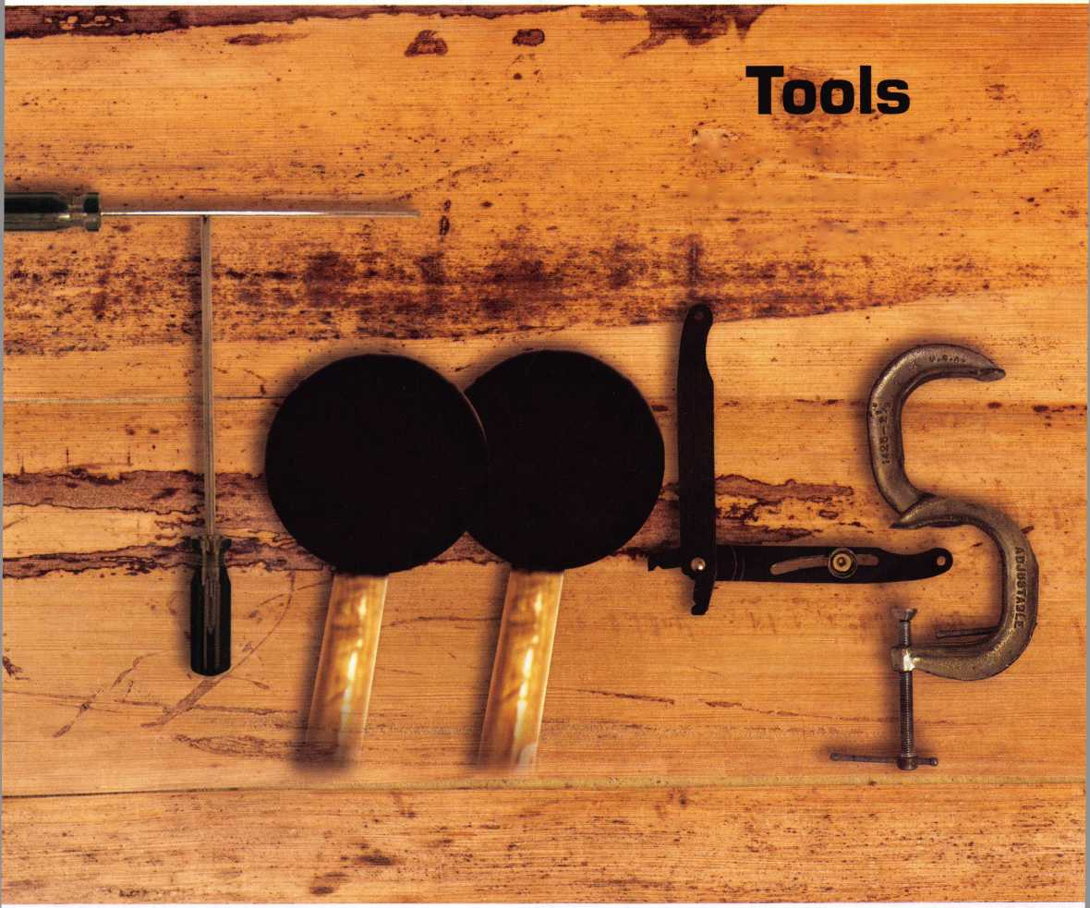

**OUR STAND**

IT'S QUITE POSSIBLY YOUR MOST

TRUSTED SIDEKICK.

**Keep it in Good Hands® with Allstate.**

As a small business owner, there are few things you rely on more than your vehicle to keep you going. Your local Allstate agent can help protect it and your small business with services you need including

quick certificates of insurance, ID cards, assistanc with the claims process, and more. All from one c the most widely recognized names in the busines

**Are you in Good Hands®?**

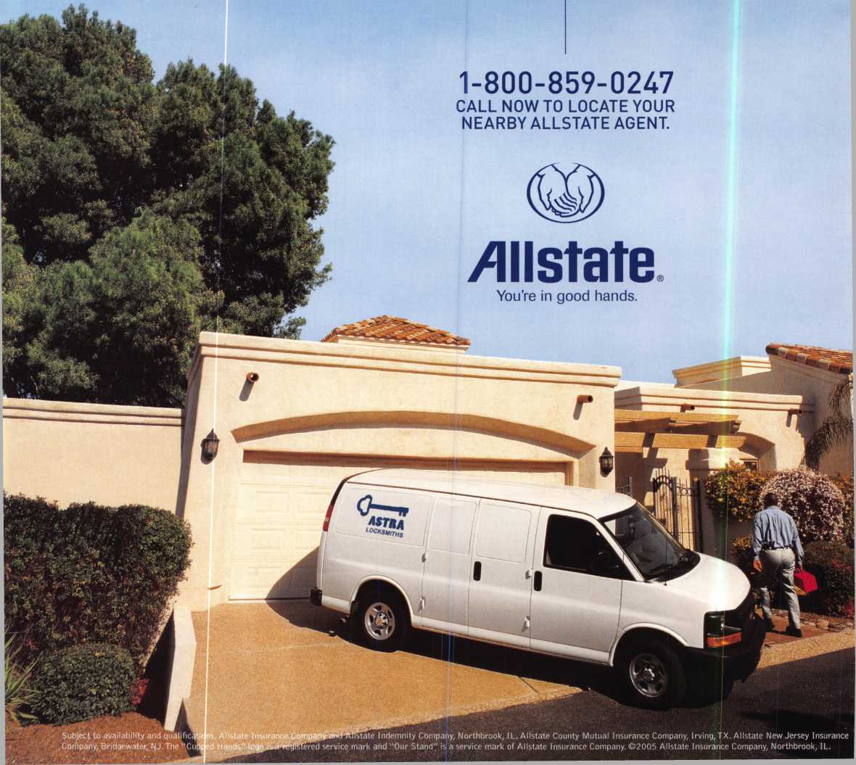

A Name You Know

As a business owner, you know the importance of a good name. Your name is your reputation. Your name stands for all that you offer in products and services. It’s a symbol of who you are. So, we thought you might like to know that Allstate, the name you know for insuring your personal vehicle and your home, also offers a business auto policy to help protect vehi­cles used in your locksmith business.

The following are coverages typically included in our business auto policy that might be important to you as a business owner:

Business Auto Liability coverage

* Higher limits up to $2,000,000 per occur­rence.
* Protects you if you are legally responsible for injuries and damages arising out of the ownership, maintenance, or use of business vehicles.
* Cost is based on several factors, including garage location, type and use of vehicle, and the violation and accident activity of your drivers.
* Additional Insured coverage may be required when you contract with govern­mental agencies or bid on local commercial jobs.
* Generally not available on a personal auto policy.
* Usually is no charge to add an insured to a Commercial Auto policy.

Hired Auto coverage

* Provides liability coverage for those vehicles you rent, hire or borrow for business use.
* The premium for hired auto liability coverage is based on the estimated annual rental cost.
* Tools and Special Equipment
* Provides protection to permanently attached equipment on your vehicle.
* You will need to let your agent know the value of the equipment to include in the cost of the vehicle.

You’re good at your business. Your insurance com­pany should be the same way.

Contact an Allstate agent to discuss your business auto insurance needs. To be referred to an agent, please call 800.859.0247 or email

**[abisO@allstate.com](mailto:abisO@allstate.com)**

Subject to availability and qualifications. Insurance coverage is subject to policy terms.

Allstate Insurance Company

Allstate Indemnity Company Northbrook, IL

Allstate County Mutual Insurance Company Irving, TX

Allstate New Jersey Insurance Company Bridgewater, NJ

allstate.com

© 2005 Allstate Insurance Company, Northbrook, IL

BETTER  
THAN EVER.

This Hawkeye® Borescope

includes all of the latest upgrades for safe and vault professionals: Optics that deliver images that rival German scopes. A new mirror technology that resists scratches from insulation, asbestos, and burrs. And a mirror protection sleeve to ward off dust.

Plus the option of the  
GRAND KIT with a fully  
configured 7” and 17”  
scope in one case. Or the  
economy minded LE model.

The red eyecup tells you that you have the scope made specifically for safe and vault professionals.

Available from Gradient Lens resellers to the safe and vault industry only.

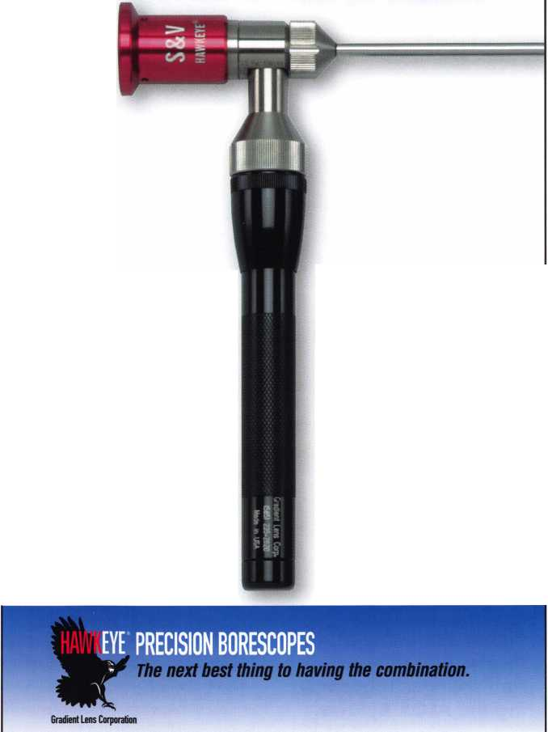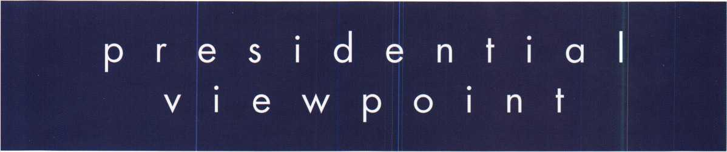

Important

Notice

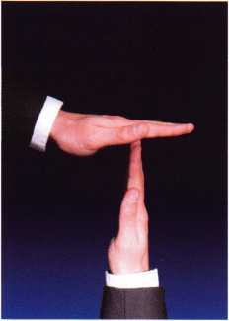

Please see Page 34 of this issue for impor­tant changes regard­ing the ALOA Bylaws.

Dear Members,

cooperation *-l.A* co-operating. 2. Collective action, as in industry; for  
mutual profit or common benefit.

In my northeast neck of the woods, leaves will soon be falling and I will be  
raking them for the compost pile. Of course, my job is easier if I have more  
than one person raking. Working together, cooperation, always lightens  
the load. The same can be said of any task that needs to be completed.

In todays world, we witness the combining of companies and corpora-

tions; this is very evident in our own security industry. ASSA/Abloy, Inger-  
soll/Rand (IR) and llco/Kaba are but a few examples of large companies encompassing twenty or thir-  
ty companies. Merging like this is not done on a whim. In combining forces, all the individual strengths  
are brought together to form a more viable and profitable organization. It eliminates waste and dupli-  
cation of effort.

Slipping away is the day when one security company can adequately fulfill all the publics needs. The  
fast-paced advance of technology and the expense of up-to-date equipment and supplies make it diffi-  
cult for most businesses to keep up. As a result, we are seeing a growth of specialists: Automotive Secu-  
rity, Electronic Access, Commercial, Residential, Institutional Locksmithing, Safe and Vault, and a myri-  
ad of other related specialities far to numerous to mention. All of these enterprises are equally impor-  
tant and valuable to the security of the public. Slipping away is the day when one local locksmith asso-  
ciation can fulfill all the needs of all its members. Some join together for mutual benefit in areas of leg-  
islation, social functions and use of equipment and space.

Over the years I have met with many groups, who through no fault of their own and for lack of the prop-  
er information, find themselves losing a lot of time, effort and money duplicating what some groups  
have already accomplished. What is sorely needed is a rallying place, a clearing house, where all  
entities can come together to exchange ideas, supply information and cooperate. What has been over-  
looked and forgotten is that the security industry has just such a place! It is called the Associated Lock-  
smiths of America.

In 1956, several forward-looking, local, independent locksmith associations gathered their resources  
to form ALOA. We need only to look at the ALOA Bylaws. Its all there in Article II. If we come togeth-  
er and bring all our talents, ideas and strengths, we cannot help but create a better company, a better  
association, a better individual. Cooperation is the key!

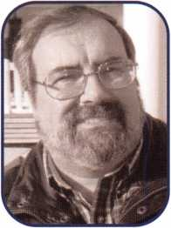

Take 'er easy.

Sincerely,



Robert E. Mock

Keynotes • October 2005

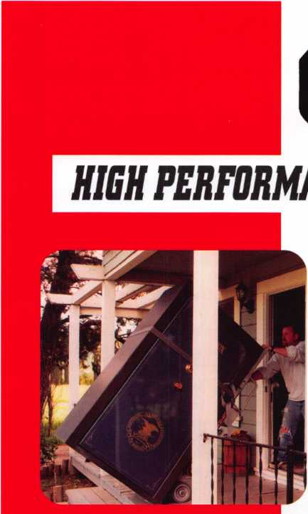

***OPERATOR SAFETY***

Injuries can be virtually eliminated. Ultra Lift does the lift­ing so that operator effort required to complete a move is minimized. Heavy loads are broken back with ease. The operator stays in control by using a combination of motor power, balance and leverage in every phase of a move.

ULTRA LIFT supplies the power — so you don't have to. One person can safely and easily handle loads that usually require 2 or 3 people, even up or down stairs. Two people can handle most safes to 1500 pounds. If safety is your concern, ULTRA LIFT is the best move you'll ever make!

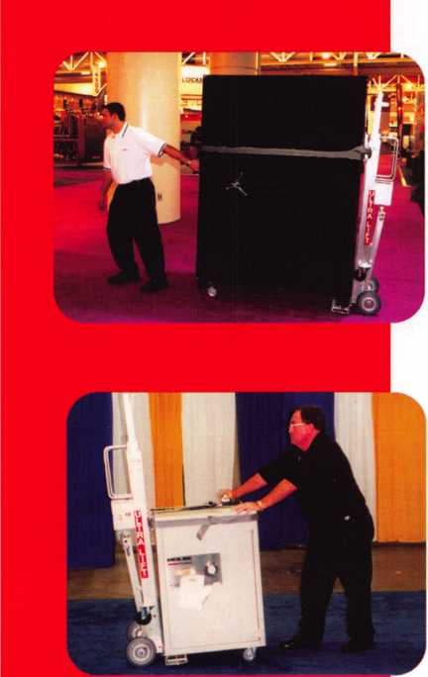

***REDUCE LABOR COSTS***

Fewer people are required for any move with Ultra Lift. Manpower can be scheduled more productively. Labor savings often pay for the Ultra Lift in one month.

***ELIMINATE DAMAGE***

Loads are broken back, set down and moved under power with maximum leverage and operator control. Gentle handling eliminates bumps, bounces and damage to the load and premises.

***INCREASE PROFITS***

Increased operator safety, reduced labor cost and elimina­tion of damage to the load and premises all contribute to significant increases in profits.

FOR LITERATURE, VIDEO OR ON-SITE DEMONSTRATION, WRITE OR CALL:

ULTRA LIFT CORPORATION

475 STOCKTON AVENUE, UNIT E SAN JOSE, CA 95126 800-346-3057 408-287-9400 FAX 408-297-1199

E-mail: [info@ultraIift.com](mailto:info@ultraIift.com) [www.uitraiiftcom](http://www.uitraiiftcom)

U.S. PATENT 4.570.953

features

TOOLS 2005



A Slick New Tool

12

Mil-Comm Products Company, Inc., the creator and manu­facturer of Lock Saver®, "The worlds finest lock lubricant", introduces its company and products to the readers of Keynotes.

The Mysterious Dominion Removable Core

The Dominion Large Format Removable Core is still today shrouded in mystery. Nothing can be found on the Internet - no factory spec sheets are available - few people around to document its existence - nothing to be garnered on locksmith websites - no real information from those "in the business". It's reminiscent of the "Mulder & Sculley - X- Files" episodes. But, now the information is being unveiled for you.

by William M. Lynk, CRL

**16**

Tackling An Antique Fire Door

Eric Costley installs an entrydoor lock on the top floor of a rennovated building.

by Eric Costley, CPL

**18**

Making the Switch

Greg Perry switches to new locks by Marks, solving a problem with a keyless mechanical combination lock.

by Greg Perry, CML, CPS

**22**



A-2 Brutus?

Small Format Interchangeable Core (SFIC) Made...Bearable

Last month we discussed terminology, the cylinder, depths and spacing, key cutting, tools. This month we will deal with the math and techniques for control pinning and core removal.

by Jim Hancock

Who Knew the Special Talents of a Locksmith?

After 25 years as a locksmith, Jon Griswold investigates other professions in which a locksmiths talents would be assets.

by Jon **B.** Griswold, CML

**34**

Bylaws Changes Update

The membership of ALOA approved, by overwhelming majority, passed seven bylaws changes this summer. Three of these changes substantially altered the requirements for membership in the association. Read the second of several installments describing these changes.

**28**

20 Years of ALOA Golf

This year at the ALOA 2005 Convention and Security Expo, Reginald Moxley, Chairman of the ALOA Open, and John Patterson, Co-Chairman retired and passed the torch to a talented new group of leaders and organizers. Read the rich history and see where it is headed in the future.

|  |  |
| --- | --- |
| r |  |
| AD INDEX |  |
| Allstate Inside Front Cover | |
| Gradient Lens | 1 |
| HL Flake | 3 |
| IR | 7 |
| Mil-Comm | 11 |
| CCL | 35 |
| American Lock | 37 |
| Turn 10 | 42 |
| PBP | 42 |
| A&B | 42 |
| Keedex | 42 |
| Payment Retriever | 42 |
| A&B Safe | 42 |
| Hinge Doctor | 42 |
| 1 Comox Back Cover | |
| L | J |

**Departments**

|  |  |  |  |  |  |  |  |  |
| --- | --- | --- | --- | --- | --- | --- | --- | --- |
| Presidential | Exc | :cutive | 5 | Calendar | 8 | Classified | 36 | Legislative 40 |
| Viewpoint | 2 Ap | plicants .... | 6 | Core | 9 | Associate Members | 38 |  |

Visit our NEW website at [www.aloa.org](http://www.aloa.org)

executive

Volume 51, Issue 10



Additional contact information for the ALOA Board and most Keynotes authors is  
available through "Locksmith Search'" on the ALOA Web site- [www.aloa.org](http://www.aloa.org) or by  
contacting the ALOA office at 3500 Easy Street; Dallas, TX 75247; (800)532-2562; FAX  
(214)819-9736; e-mail [aloa@aloa.org](mailto:aloa@aloa.org).

Editor

Betty Henderson [betty@aloa.org](mailto:betty@aloa.org)

Editorial Advisor

John Cannon, CML [jcannonl@cox.net](mailto:jcannonl@cox.net)

Advertising Sales

Kim Hammond voice: 817-645-6778

Fax: 817-645-7599 e-mail: [adsales@aloa.org](mailto:adsales@aloa.org)

Executive Director

Charles W. Gibson, Jr., CAE [charlie@aloa.org](mailto:charlie@aloa.org)

Associate Executive Director

David Lowell, CML, CMST [david@aloa.org](mailto:david@aloa.org)

Convention & Meetings Manager

Jo Anne Mims [joanne@aloa.org](mailto:joanne@aloa.org)

Operations/Membership Manager

Mary May [mary@aloa.org](mailto:mary@aloa.org)

Director of Creative Services

Betty Henderson [betty@aloa.org](mailto:betty@aloa.org)

IT Operations Manager

Greg Jackson

Comptroller

Membership Coordinator

Convention & Meetings Assistant  
PRP/Education Coordinator

Mail Room Coordinator

Creative Media Specialist  
Accounting Coordinator

Executive Assistant

Assistant Education Manager  
Legislation Manager

Contributors

Jerome Andrews, CML  
Paul Chandler, CRL  
Claire Cohen, CML  
Brian Costley, CML, CMST  
Eric Costley, CRL

Ray D'Adamo, CML Billy Edwards, CML Dan Graffeo, CRL,CMST Jim Hancock, CPL Jeff Nunberg, CML, CMST

Randy Simpson, CML, CPP Robert Stafford, CML Dave Thielen, CML Greg Perry, CML,CPS

[greg@aloa.org](mailto:greg@aloa.org)

Kathy J. Romo

Shelly Jett

Karen Lyons

Hope Rodriguez

Kevin Wesley

Bryan Dease

Joyce Nixon

Sue Langford

Bob Stafford

Tim McMullen

Tom Seroogy

Charles Stephenson, CPS

Dennis Watanabe, CML, CMST

Mission Statement: The Associated Locksmiths of America, Inc. is dedicated to enhancing the professionalism, education and ethics among  
locksmiths and those in related sectors of the physical security industry. With approximately 10,000 members in the United States, Canada and the  
freeworld, ALOA is poised to help members obtain the knowledge, the strength, and the confidence to perform their role in the physical security field  
with pride and dignity. But it is only through active involvement and participation that ALOA can fully achieve its potential—and can help members to  
achieve theirs.

Policies: Keynotes® is the official publication of the Associated Locksmiths of America, Inc. (ALOA). Keynotes® acts as a moderator without approving,  
disapproving, or guaranteeing the validity or accuracy of any data, claim, or opinion appearing under a byline or obtained or quoted from an acknowl-  
edged source. The opinions expressed by the authors do not necessarily reflect the official views of ALOA. Also, appearance of advertisements and  
new products or service information does not constitute an endorsement of products or services featured by the Association. The Association does not  
accept responsibility for the inaccuracy of any data, claim, or opinion appearing in this publication, due to typographical errors on the part of the  
authors, Association staff or its agents.

Editor's Note: This publication is designed to provide accurate and authoritative information in regard to the subject matter covered. It is provided  
and disseminated with the understanding that the publisher is not engaged in rendering legal or other professional services. If legal advice and other  
expert assistance is required, the services of a competent professional should be sought.

Authors' Payment: Payment for eligible submissions to Keynotes will be based on the following criteria: topic, time spent and past contributions. Authors who  
regularly submit to Keynotes19 are generally paid a higher rate. The latter is especially true of authors who write to fit specific editorial needs and submit said copy  
by Keynotes9 deadlines. As a general guideline: Average payment for a 750 word, business or 'light' technical article would be $200. Payment for a 1500 word  
article involving significantly higher time and research efforts would be $400.

Payment will not be offered for articles submitted by ALOA employees or members of the ALOA Board of Directors (unless material is of a technical  
nature), nor for articles submitted by a company that promote that company's products or services. ALOA reserves the right not to pay for articles sub-  
mitted by an individual(s) that promote a particular company's products or services.

Disclaimer: The Associated Locksmiths of America, Inc., (ALOA), reserves the right to refuse any article for any reason. Additionally, ALOA reserves  
the right to edit, amend or modify any article submitted for publication in order to preserve technical accuracy, clarity, fairness or grammatical cor-  
rectness. ALOA will make the best efforts to notify the author of any changes. The extent of ALOA's liability for any article or information contained  
therein will be a notice of correction or retraction in the next possible issue.

Keynotes9 (ISSN 0277 0792) is published monthly except for the combined June/July issue by The Associated Locksmiths of America, Inc.,  
3500 Easy St., Dallas, TX 75247-6416. Telephone: (214) 819-9733; FAX (214) 819-9736; e-mail [aloa@aloa.org](mailto:aloa@aloa.org). Subscription rates for  
members—$15.00 per year. Periodical class postage paid at Dallas, Texas. POSTMASTER: Send address changes to: Keynotes, 3500 Easy St., Dallas,  
TX 75247-6416. © Copyright 2003, All rights reserved. No part of the contents may be reproduced or reprinted in any form without prior  
written permission of the publisher.

President

Robert Mock  
(856) 863-0710  
[president@aloa.org](mailto:president@aloa.org)

Secretary

John Soderland, CML, CMST  
(414) 327-5625  
secretary@aioa. org

Directors, Northeast

Peter Sarailian, CRL  
(973)890-9797  
[nedirector@aloa.org](mailto:nedirector@aloa.org)

Vernon Kelley, CPL

1. 771-3126 nedi rector@aloa. org

Directors, Southeast

Tom Gillingham, Jr., CML, CPS  
(615)264-0747  
sedirector@afoa .org

Ken Kupferman, CPL  
(813)961-5784  
sedirector@aloa .org

Director, North Central

William Smith, RL

(920)893-5282

Guy,Spinello, RL  
(815)229-1000  
ncdirector@aloa. org

Director, South Central

CD Lipscomb, CML, CPS  
(903)874-3522  
[scdirector@aba.org](mailto:scdirector@aba.org)

Directors, Southwest

Gordon R. Racine, CML  
(719) 384-4707  
[swdirector@aloa.org](mailto:swdirector@aloa.org)

Julie McCluney, CRL  
(714) 636-5652  
swdi rector@aloa. org

Director, Northwest

Jim Jeffries, CPS  
(208)743-1101  
[nwdirector@aloa.org](mailto:nwdirector@aloa.org)

Director, European

Hans Mejlshede, CML  
(453)539-3939  
[eurdirecfor@aloa.org](mailto:eurdirecfor@aloa.org)

Director, Asian

Joe j. Lee, CRL  
(215)289-2404  
asiandirectar@afoa. org

Director, Associate

Paul M. justen  
(800)333-6953  
asdirector@aloa. org

Trustees

trustees@aloa. org

Randy Simpson, CML  
(281)240-5959

John J. Greenan, CML, CPS  
(773) 486.2030

William Young, CML, CPS

1. 647-5042

Past Presidents

2003-2005 William Young, CML, CPS  
2001-2003 Randy Simpson, CML  
1999-2001 John Greenan, CML, CPS  
1997-1999 Dallas C. Brooks  
1995-1997 David Lowell, CML, CMST  
1993-1995 Breck Camp, CML  
1991-1993 Henry Printz, CML  
1989-1991 Evelyn Wersonick, CML, CPS  
1987-1989 Leonard Passarello, CPL  
1985-1987 Joe Jackman, CML  
1983-1985 Stanley Haney, CPL  
1981-1983 Louis LaGreco, CPL  
1979-1981 John Kerr, RL  
1977-1979 Clifford Cox, CML  
1974-1977 Charles Hetherington  
1972-1974 Gene Laughridge  
1970-1972 William Dutcher, RL  
1968-1970 Constant Maffey, RL  
1966-1968 Harold Edelstein, RL  
1964-1966 William Meacham  
1962-1964 Robert Rackliffe, CPL  
19601962 Edwin Toepfer, RL  
1956-1960 Ernest johannesen



Keynotes • October 2005

AK

OH

Canada

Anchorage

Kevin S. McKinney

Sponsor: Scott L. Henke CPL, CPS

AL

Athens

Dwight Kennedy

Sponsor: Dulin Sherman CPL

AZ

Phoenix

Philip Hilliker

Sponsor: Mark I. Kessman CRL

CA

Chula Vista

David Buckingham

Sponsor: Larry Block Jackson

Robert R. Wood II

Sponsor: Lawrence S. Vanselow San Jose

Barrett Brockhage

Sponsor: Pablo M. Mediavilla San Ramon

William L Tessendorf

Sponsor: Bruce P. Eagan CML Upland

Todd D. Sickinger

CT

Jewett City

Paul Snurkowski

Sponsor: John K. Humphreys CRL Ridgefield

Bryan Gregg

Sponsor: Ernest Lay CPL

FL

Gainesville

Adam H. Perkins

Sponsor: Charles E. Batcke CRL, CPS Spring Hill

Daniel J. Wright

GA

McDonough

Kenneth Deyton

Norcross

Asher Uziel

Savannah

Zelma A. Rahn

Sponsor: Bruce T. Rahn Stockbridge

Stephen A. Hardy CRL

Sponsor: Harold L. Hardy CRL

HI

Honolulu

Young K. Lee

ID

Moscow

Elmo E. Nelson III

Sponsor: Elmo E. Nelson



Highland Park

Patrick T. McGahan

MA

Rehoboth

Raymond Burt

MD

Frederick

Craig Smoot

Sponsor: Charles C. Robertson CML Upper Marlboro

Andrew DiMiceli

Sponsor: James Maryon CRL

Ml

Clio

Gary C. Ridley

Sponsor: Charles E. Batcke CRL, CPS

Roberts

Sherrie A. Nevill

West Yellowstone

Greg Hitzler

Sponsor: Jim L. Jeffries CPS

NM

Albuquerque

Michael J. Morrow

Artesia

Cary D. Roberson

New York

Christian Lyon

Cardington

John C. Hazen

Sponsor: William T. Beranek

OR

Klamath Falls

Gregory J. Cheyne

PR

Carolina

Carlos Acevedo

Sponsor: Carlos Ortiz

*SC*

Charleston

Eric N. Lentz

Sponsor: Willie D. Gamble Florence

Jason L Young

TN

Lebanon

Donald G. Willis

TX

Flower Mound

C Daniel Porter Jr, CRL

VA

Leesburg

Thomas E. Orrison

Sponsor: Alfred W. Ryan Stephens City

Ronald W. Sandretzky Andrew A. Pitts Woodbridge Jonathan C. Malloch

WA

Blaine

Todd A. Ives

Sponsor: James L Hancock CPL Kent

Kyle R. Klingler

Sponsor: Jim Williams CRL Newport

James L Jeffers CML

Wl

Menomonee Falls

Warren Simonsen

Sponsor: Mark B. Whitlow CRL

ON

Brampton

Glen S. Clifford

Sponsor: Donald H. Shiles RL

China

Hong Kong

Wing Cheong Ho

Sponsor: Carroll T. Mann

England

RCT Wales

James P. Yeomans

Sponsor: Ken Dale

France

Romans Cedex Drome

Doucet Yann

Mexico

Acambaro, GTO.

Jose Luis Castro Campuzano Autlan DeNavarro,Ja Jesus Salvatierra Delgado Can Cun, Q.Roo Oscar Neri Alcibar Cuernavaca Morelos Armando Valdez Vazquez Guillermo Albarran Cuevas Jose Arturo Perez Soto Cuernavaca, Mor.

Israel Moises Romero Melgar Javier Cruz Garcia Cuernavaca, Morelos Martin Tomas Iglesias Garcia Santiago Cesar Ayala Franco Guadalajara, Jalisc Norberto Arizaga Campoy Ramon Lopez Lopez Adisaid Santiago Medrano Maravatio, Michoaca Luis Alfonso Castro Mora Morelia, Mich.

Erik Avalos Bedolla Naucalpan

Victor Salvatierra Delgado Pachuca, Hidalgo Roberto Solis Marquez

Puebla

Antonio Alonso Huerta Miguel Hernandez Silva Tizapan San Angel Leonardo Nciva Martinez

Sponsor: Eliseo Barajas Toluca

Arturo Arizmendi Apolinar Eduardo Sebastian

Jacinto

Valle Gomez

Juan Carlos Hinijosa Estrada

Veracruz

Rafael Morales Mtz.

Zapopan, Jalisco

Donaldo M. Gomez Sanchez Lazaro Avendano Vicente Jose Luis Apanco Paulino Rios Delgado Pablo Ruiz Mendoza Sandro Alejandro Hernandez Perez

Juan Manuel Aguilar Zavala Eduardo Colin's Ricardo Villanueva Rodriguez Juan Carlos Gutierrez Reyna Sergio Flores Aaron Zarate Gonzalez Alejandro Guerrero Chavez Victor O. Lopez Renedo Freddy Ovando Castillo Raul Robles Vazquez Alberto Rico Ortega Luis Rogelio Sanchez

Sweden

Goteborg

Jan R. Thorner

Sponsor: Rex E. Parmelee RL

Taiwan

Taipei

Anne L F. Lin

Sponsor: Dong-Hoon Song

These applicants are scheduled for clearance as members of ALOA. The names are published for member review and comment within 30 days of this Keynotes issue date, respectively, to ensure  
applicants meet standards of ALOA's Code of Ethics. Protests, if any, should be addressed to the Membership Department and must be signed. Active Membership applicants (a) have worked in  
the industry two or more years. Allied Membership (AL) applicants are not locksmiths, but work in a security-related field. Apprentice Membership (AP) applicants have worked in the industry less than two years.

Keynotes • October 2005

**SECURITY HOMEOWNERS WANT. That’S WHY IT’S ALL YOU NEED TO CARRY.**

*Introducing the Schlage Accents™ Collection*

Schlage now provides you with the ability to retrofit virtually any door with the ultimate in elegance and security. The Schlage Accents collection is built on a revolutionary chassis designed to provide field-reversible levers on passage, privacy and now keyed functions. A patented adjustable through-bolt allows Schlage Accents handlesets to retrofit over 70% of competitors’ current designs. Special features like these, along with concealed screws and decorative trim, allow you to reduce the inventory you carry while providing the perfect door hardware choice for homeowners who desire Schlage quality and security.

To find out more about the finest line of decorative door hardware, visit schlageaccents.com.

**An<yfDlngersollfland business**

**© 2005 Ingersoll-Rand**

|  |  |  |  |  |
| --- | --- | --- | --- | --- |
| I i nil t 1 * r I | I t I f |  |  | m i |
| •frlpl ;({i  II J > f i 1 ; I I f | | Jttf;  1 1 fi I |  |  |  |
| liiif:Ji 111f n | I i'll |  |  |  |
| llll i-4- -i |  |  |  |  |

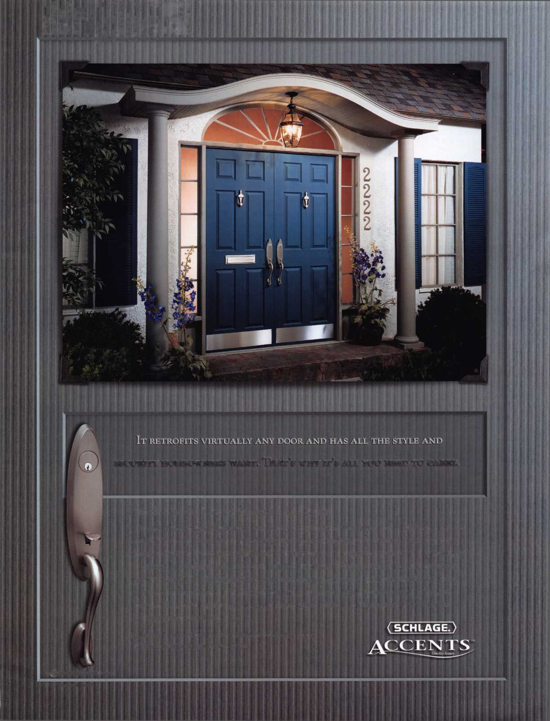

**DECEMBER I NOVEMBER I OCT**

**u p c o m**

events

i n g

|  |  |
| --- | --- |
| 11-15 Pacific Locksmiths Association 2005 Conference  Portland, Oregon  ACE Classes, PRP Exam,  Trade Show | 19 NJMLA Monthly Meeting. 24-29 6-Day Basic Locksmithing 27-29 GPLA 56th Annual Convention-  Third Wednesday of every month. Fox Valley Technical College Mount Laurel, New Jersey  Call (201 )944-7547 or Appleton, Wl 54912-2277 Contact: Robert Schuetrumpf, CRL  (201 )947-6291 for time Contact: Ann Kading 856-486-9280  and location. 1-800-735-3882 x2482 |
| 2-5 Yankee Security Convention ACE Classes, Trade Show & PR Sturbridge, MA | 4 Greater Houston Locksmiths Assn 5 Greater Houston Locksmiths Assn 16 NJMLA Monthly Meeting.  3 Automotive tips & tricks / All day auto hands-on class Third Wednesday of every month,  open forum For registration info contact: Judy Call (201)944-7547 or  For registration info contact: Judy Clifford, phone 979-297-2413 (201)947-6291 for time  Clifford, phone 979-297-2413 and location. |
| 18 ALOA Open House  3500 Easy Street  Dallas, Texas 75228 10a.m.-4p.m. |  |
| 5-10 Dallas, Texas  Six-Day Basic  Locksmithing Course  Contact: Hope Rodriguez Phone: 800-532-2562x104 | 21 NJMLA Monthly Meeting.  Third Wednesday of every month.  Call (201)944-7547 or (201)947-6291 for time and location. |
|  |  |

**UPCOMING ACE CLASSES**

UPCOMING PRP SITTINGS

|  |  |  |  |
| --- | --- | --- | --- |
| 10/11-15/2005 | Portland, Oregon • Pacific Locksmths Association  Bill Botek, CRL 503-644-9881  Life Safety Codes w/L07 PRP | 10/02/2005 | Sunday 8:00 am* De$ Moines, IA • Iowa Locksmith Association  Harry Russell 319-338-8735 |
|  | Fundamental Locksmithing (2 days)  Servicing Aluminum Storefront Doors  Safe Combination Lock Servicing | 10/02/2005 | Sunday 10:00 am • Carlsbad, NM • Associated Locksmiths of New Mexico • Roy Haynes, CRL • 505-746-2133 |
|  | Basic Electricity w/LI 3 PRP  Advanced Shop Management  Professional Impressioning Techniques | 10/08/2005 | Saturday 9:00 am • Colorado Springs, CO • Central & Southern Colorado Locksmith Assn ‘Gordon Racine, CML 719-384-4707 |
| 11/2-5/2005 | Sturbridge, MA • Yankee Security Convention {9 classes)  Jack Hobin, CPL, • [info@yankeesecurity.org](mailto:info@yankeesecurity.org) | 10/09/2005 | Sunday 9:00 am • Orlando, FL • SERLAC 2005  James Barnhardt, RL 813-689-5979 |
| 11/12/2005 | 800-209-8266  Detroit, Michigan • Locksmith Security Association • Robert C. | 10/13/2005 | Thursday 9:00 am • Dallas, TX • ALOA  Hope Rodriguez 800-532-2562 |
| 11/19-20/2005 | Nobel, CML 810-385-9329 Large Format 1C w/L-39 PRP | 10/14/2005 | Friday 6:00 pm • Portland, Oregon • Pacific Locksmiths Association  Bill Botek, CRL • 503-644-9881 |
| St Louis, Missouri • BiState Chapter of ALOA • |  |
|  | Basic Auto Transponders Systems  Advance Transponders Systems & Keyless Remotes  Robert Theobold 314-340-6804 | 10/30/2005 | Sunday 10am • Mt Laurel, NJ • GPLA  Robert Schuetrumpf, CRL 856486-9280 |
| 12/5-10/2005 | Dallas, Texas • ALOA ACE Program  Hope Rodriguez 800-532-2562 xl04  6 day basic locksmithing course | 11/5/2005  11/10/2005 | Saturday 9:00 am • Sturbridge, MA • Yankee Security Convention  Jack Hobin, CPL • 800-209-8266  Thursday 9:00 am • Dallas, TX • ALOA  Hope Rodriguez 800-532-2562 |
|  |  | 11/12/2005 | Saturday 8:00 am • Cary, NC • North Carolina Locksmiths Association Granger L. Marley, CML 919-859-6060 |
|  |  | 11/13/2005 | Sunday 8:00 am • Baltimore, MD • Clark Security Products  Joan Emrick 619-718-7308 |
|  |  | 11/19/2005 | Saturday 6:00 pm • Bi-State Chapter of ALOA •  Kenneth Kim, CRL, CPS 314-351-7252 |
|  |  | 12/08/2005 | Thursday 9:00 am • Dallas, TX • ALOA |

Hope Rodriguez 800-532-2562

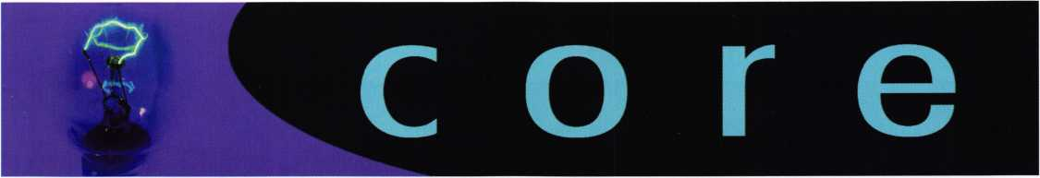

Former ALOA President Receives  
National Honor

Former ALOA President. Constant "Connie" Maffey was  
recently awarded the Distinguished Flying Cross medal  
from the United States Air Force. Throughout history, the  
medal has been awarded to such greats as Charles  
Lindbergh and Amelia Earhart.

Mr. Maffey received the Distinguished Flying Cross medal  
for his quick thinking as Flight Engineer on a B-24  
bomber headed for Nazi Germany on February 25,  
1945. During take off, one of the plane's four engines  
failed, causing Maffey to make quick adjustments, to  
ensure a continued flight on "The Liberator".

The Pilot of The Liberator, James Dulitz recommended Mr. Maffey for the award in  
1945 but with the end of the war, the paperwork was lost or forgotten. Sixty  
years later, Mr. Dulitz was able to finish what he started with the help of his local  
congressman.

Mr. Dulitz recounted  
the events leading up  
to Mr. Maffey's heroic  
actions, "As we  
reached the end of  
the runway, we were  
still several mile-per-  
hour short of takeoff  
speed. Maffey real-  
ized that the standard  
adjustment would not  
give us sufficient  
power for take-off  
and, without orders,  
adjusted each turbo

individually." He wend on to explain that Maffey's actions helped the plane gain enough speed to bounce over a ditch, go through a farmer's fence and finally become airborne.

When asked about his heroic actions, Maffey humbly stated, "I was just doing my job."

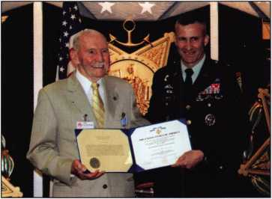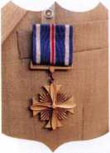

Lock Museum of Orange County

The Lock Museum of Orange County recently received special attention from the Los Angeles Times in a story entitled, "Museum of a Lock-Tested Master". The arti­cle describes one of the largest collections of handcuffs, leg irons, and restraints "west of the Mississippi". The museum's de facto curator (and ALOA Board Member), Julie McCluney listed some of the items: locks from Harry Houdini's col­lection, torture items such as leg irons and neck cuffs with protruding spikes, a lock that secured Elvis Presley's dressing room at the MGM Grand Hotel Las Vegas, three locks from Hearst Castle, 5000 padlocks, 175 handcuffs, 100 time locks, 900 mounted lock samples and an inner vault cage door salvaged from Wells Fargo Bank in San Francisco after the 1906 earthquake.

For more information on the museum, contact George Hill or Julie Hill McCluney at Hill's Bros. Lock and Safe in Garden Grove, California.

ALOA Open House

Be the first on your block to get an inside view of ALOA's new headquarters office. Join us for an open house November 18, 2005, 10 a.m.-4 p.m.. Call (800)532-2562 for more details.

Wisconsin Celebrates Professional Locksmiths Week

Jim Doyle, Governor of  
Wisconsin recently  
declared October 3-9  
2005 as Professional  
Locksmiths Week to coin-  
cide with the observance of  
October's National Crime  
Prevention Month. The  
proclamation reads: "  
Whereas, professional lock-  
smiths dedicate endless  
hours of time and almost  
unlimited finds to advance  
their education in certified  
Associated Locksmiths of  
America (ALOA) courses;  
and

Whereas, professional lock-  
smiths respond to calls 24  
hours a day, 7 days a  
week, 365 days a year;  
and

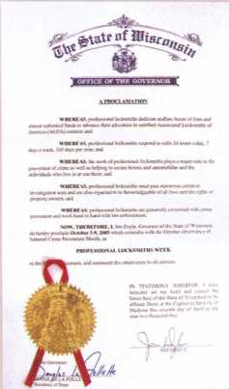

Whereas the work of a pro­fessional locksmiths plays a major role in the prevention of crime as well as helping

to secure homes and automobiles and the individuals who live in or use them; and

Whereas, professional locksmiths must pass numerous criminal investigation tests and are also expected to be knowledgeable of all laws and the rights of property owners; and

Whereas, professional locksmiths are genuinely concerned with crime prevention and work hand in hand with law enforcement,

Now, therefore, I, Jim Doyle, Governor of the State of Wisconsin, do hereby pro­claim October 3-9, 2005 which coincides with the October observance of National Crime Prevention month, as

Professional Locksmiths Week

in the State of Wisconsin, and commend this observance to all citizens.

Discovery Channel Busts Lock Myth

It's a tough job separating truth from urban legend but Mythbusters has taken on the challenge. Each week special-effects experts Adam Savage and Jamie Hyneman take on three myths and use modern-day science to show you what's real and what's fiction. They do more than explain how something may or may not be scientifically possible. Through trial and error they actually demonstrate it.

Recently, this popular television show contacted ALOA's Assistant Education Manager, Robert Stafford, to enlist help debunk certain legends involved with Benjamin Franklin and his famous key. Check your local listings this season for dates and times of this showing.

In the meantime, don't miss these two experts attempt to ignite a fire with a cell phone or explode a toilet every Wednesday at 9 p.m. ET/PT on the Discovery Channel.

ALOA Member in the News

ALOA member Roy Watters receives national attention for his safecracking skills: <http://www.businessweek.com/magazine/content/05_25/b3938463.htm>



Keynotes • October 2005

A Slick New Tool

'LOCK

[?5%MORi™

I o?, for 11.00

LOCK SAVER/

LUBRICANT  
PROTECTANT  
FOR ALL LOCKS

**&c**ellent Corrosion ***Protection***

LOCKS A

jnrM CMifPfh **Lubr,cant protect# VWWI ^■¥5' for all locks**

binges, doors. valves:~Zt« chains. and all squeaky P**

#UMMAWf *am£NTSI^0^^*

'S!'^QK7 * 6 WT. OZ. (243.8 g> i12 « ^ W'

"** 8 ounces (22? S'**

CLEANER

**degreaser**

4 a **oi.(**1 20 n*

Mil-Comm Products Company, Inc., the creator and man­ufacturer of Lock Saver®, “The worlds finest lock lubri­cant”, introduces its company and products to the readers of Keynotes. Although new to the lock industry, Mil- Comm is a well-established U.S. Defense Contractor that has been innovating, formulating and manufacturing spe­cialty high-performance lubricants for the U.S. Military and its NATO allies since 1985. Mil-Comms original for­mula, TW-25B®, gained widespread approval from the troops and U.S. Department of Defense during Operation Desert Storm because it performed so well in the harsh heat and scorching sands of the desert. It is also both non­toxic and environmentally friendly.

In 2004, the U.S. Department of Defense awarded Mil- Comm the highly-competitive, “10 Year, Sole Source” sup­

ply contract. Today, TW25B® and its derivatives are lubri­cating the most critical performance hardware systems on the land, on the sea and in the air. Mil-Comm’s customer base has grown to include federal, state and local law enforcement agencies, professional gun enthusiasts and weapons manufacturers throughout the world. As the com­pany grew, Mil-Comm introduced this unique, innovative technology to the Marine market with the creation of the Reel Saver®, Boat Saver® and Line Saver® brands.

Early this year, with twenty years of experience making lubricants, Mil-Comm proudly introduced this advanced technology to the commercial lock market with the launch­ing of Lock-Saver®, the lubricant protectant for all locks. This innovative product line of all synthetic lubricants was developed and formulated in response to the needs of the

Keynotes • October 2005

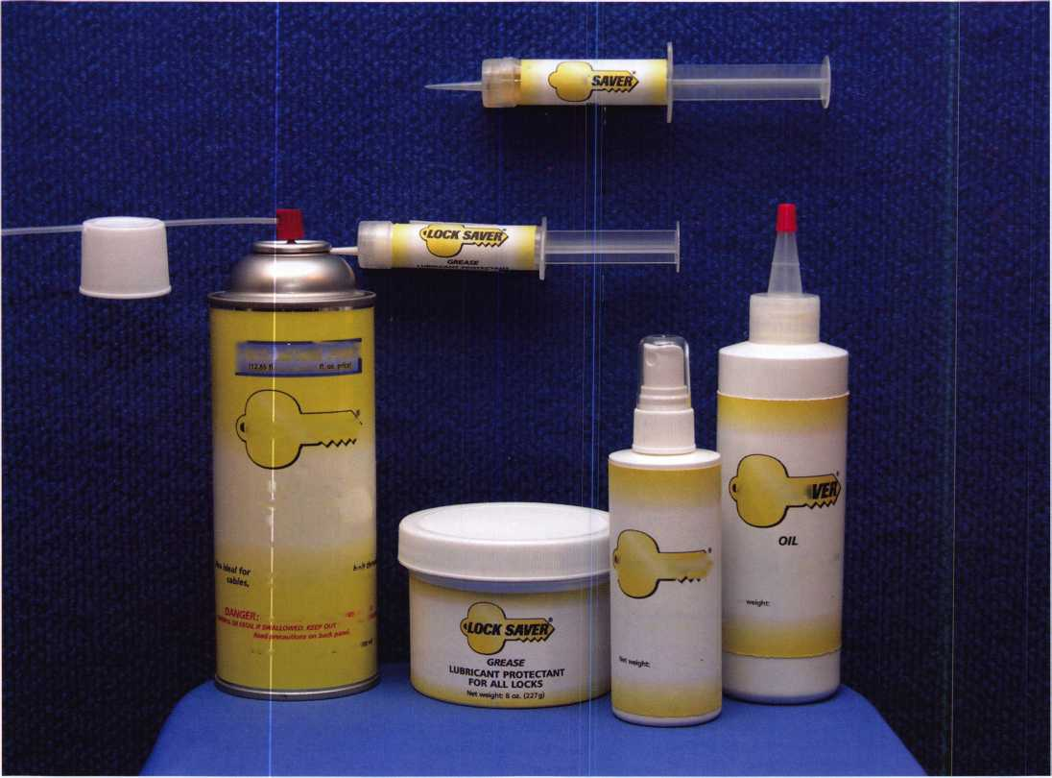

Federal Bureau of Prisons and other branches of law enforce­ment, who had previously adopted specialty lubricants for use on everything from handcuffs to prison locks.

Since its debut in March 2005, Lock Saver® aerosol has earned enthusiastic approval by the prison hardware mainte­nance community and by commercial locksmiths for its exceptional performance lubricating all kinds of locks. Users enthusiastically endorse Lock Saver® because, unliked most other lock lubricants, it is long lasting, environmentally friendly and not petroleum based.

Lock Saver® lubricants employ special nano-technology to repel both sand and grit, preventing the internal lock mecha­nisms from clogging up with a build-up of debris. Lock Saver® also works reliably in an extremely wide range of tem­peratures from -65°F to +450°F. As demonstrated at the the ALOA 2005 Convention and Security Expo with dry ice, Lock Saver® lubricant will not freeze or attract moisture. It remains malleable, sloughing off ice crystals with ease.

The Lock Saver® product line now includes a lubricating grease, an oil and a water-based cleaner and degreaser that emulsifies organics on contact in addition to our Lock Saver® aerosol. Lock Saver® grease and Lock Saver® oil are both

available in a convenient syringe and traditional packaging to meet the needs of locksmiths® in the shop, on the job or on the road.

Mil-Comm is proud to announce that several major lock manufacturers will soon incorporate Lock Saver® lubricants into their production process. Lock Saver® lubricants are the latest innovations in Mil-Comms twenty year history of for­mulating, manufacturing and marketing superior perform­ance, non-hazardous lubricants in the U.S.A.

Lock Saver® saves locksmiths time and money. Once applied to lock mechanisms, Lock Saver® greatly reduces or elimi­nates those costly customer “no charge” service calls as it pro­vides long-lasting reliability of parts.

Lock Saver® products will only be distributed through the professional locksmith trade, providing a unique product line that locksmiths can use on the bench, take on a service call, or sell to the customer as an add-on to the call or in the lock­smiths shop.

For further information about Lock Saver® lubricants and Mil-Comm Products, please visit [www.mil-comm.com](http://www.mil-comm.com) or call toll free at (800)743-4518.

'LOCK SAVEi

i5% MORE FR££

LUBRICANT PROTECTION  
FOR ALL LOCKS

World's Finest Synthetic Lubricant

Long Lasting Lubrication & Protection

MADE IN THE USA

H0CKSA

LUBRICANT

**Protectant**

f°R **all locks**

Corrosion Protect

doors.

‘ and all sq***1#^

Environmentally Safe, Non-Toxic Will Not Gum Up or Clog Up For All Lock & Key Combinations

**to**

* Will Not Attract Dirt, Water or Debris
* Works Well in All Climates
* Temperature Range: -65°F to +450°F

TOLL FREE: 800.743.4518

Mil-Comm Products Company, Inc. Visit Our New Website: [www.mil-comm.com](http://www.mil-comm.com)

Keynotes • October 2005

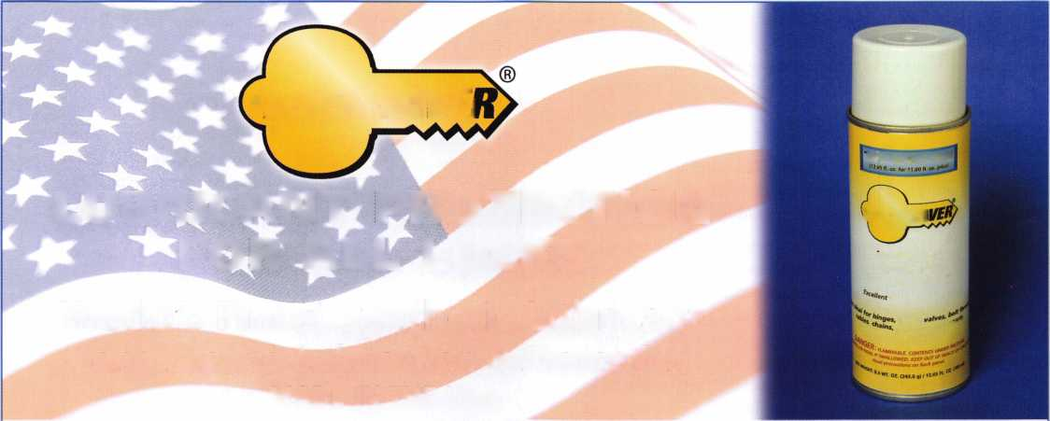

The Mysterious Dominion Removable Core

By William M. Lynk, CRL

The Dominion Large Format Removable  
Core is still today shrouded in mystery.  
Nothing can be found on the Internet - no  
factory spec sheets are available — few peo-  
ple around to document its existence -  
nothing to be garnered on locksmith web-  
sites - no real information from those "in  
the business ". It's reminiscent of the

"Mulder & Sculley - X-Files" episodes. But, now the information  
is being unveiled for you. The "quiet time" has now ended and  
the facts speak for themselves.

History

The Dominion Removable Core has been around for a multitude of years. Dominion Lock Company, Ltd. of Montreal, Canada, once manufactured it but, as many are aware, Ilco-Unican bought Dominion Lock. Since then, things have changed.

In 1933 a manufacturing plant was begun in Montreal. It was named Dominion Lock Co, Ltd. Their claim to fame was manu­facturing key blanks and night latches used by the Canadian and British markets. Key machines were also produced and had a presence in the U.S. market.

In the year 1963, a new corporation was founded in Montreal. It was called "Unican Security Systems, Ltd." and the renowned Aaron M. Fish was named President & Chairman of the Board. Twenty-two years later, a purchase would be made.

In April 1983, ILCO acquired the assets of Dominion Lock Company Ltd. (Dominion Lock), Canada's major manufacturer of key blanks, including brass replacement key blanks. Key blanks were produced at the old Dominion Lock factory on Decarie Blvd., which was also used to assemble push-button locks and electronic card access systems. ILCO was the sole Canadian manufacturer of brass replacement key blanks between 1989 and 1991. In May of 1991, ILCO ceased production of key blanks and then, in February 1992, resumed production.

Dominion Lock, which had been manufacturing key blanks in Montreal for over 70 years, now operates as a division of ILCO. The rest is documented history.

Terminologies

Terms for locks are an ever-changing issue and are being studied constantly. Many feel it's a "monkey on the back". But, in reality, it is something that we need to address and discuss. This article

I

could go on and on about manufacturer-specific terms, user-spe-  
cific terms and the hybrids that occur in between. Let it be said  
that the LIST Council has determined the appropriate termi-  
nologies that should be used within the Lock Industry, and,  
within its peripheral realms. The LIST Council is an acronym  
that stands for "Lock Industry Standards & Training" Council. It  
is comprised of a number of representatives from within the  
locksmith industry who review lock-related terminology.

The term "Removable Cores" has a specific meaning via the  
LIST Council. However, Dominion chose to utilize this term as  
does Sargent, ILCO and other manufacturers today. With respect  
to historical accuracy, we shall honor the use of this term. As the  
lock and security industry evolves, terminology also evolves.  
Considering all of the massive company buy-outs and the exten-  
sive retrofitting that goes on today, we should be open to chang-  
ing our terminologies and applying them to what is current and  
applicable. Many terms have changed in their usage, and others  
are brand new. The appropriate thing to do is to match the past  
with the present and make meaningful adjustments. Will this  
happen? Time will tell.

The Dominion Removable Core

The Dominion Large Format  
Removable Core (RC) is not  
unlike the old Sargent 5100  
Series R-Core in basic concept.  
In both situations there exists a  
rear mechanism that acts as a  
"control area". In the  
Dominion core (a six-chamber  
core), there is a control ring in  
the last chamber that has a con-  
trol lug attached to it. This lug,  
when in its relaxed state  
(extended), keeps the core with-  
in its housing. When the con-  
trol key activates the control  
ring, the lug turns to the left  
(counterclockwise) and recesses

into the core assembly, allowing the R-core to be removed from  
its housing. Within the Dominion core, the sixth chamber can  
also be used for operating key bittings. This is not the case with  
the Sargent 5100 Series core. As you may presume, bittings are  
then limited and care must be taken when combinating the con-  
trol chamber.

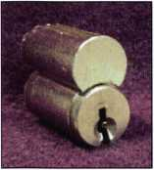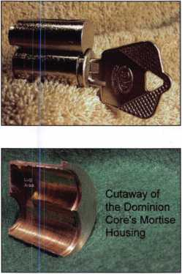

**2**

Keynotes • October 2005

The direction of the moveable control ring/lug is similar to a Sargent R-Core lug or a Medeco R-Core lug. The control key must be turned counterclockwise (to the left) in order to retract the core. This is opposite to BEST, Yale, CorbinRusswin, Schlage, KABA and some of the other popular brands. Let's take a look at the lock specifics with regard to mechanical specifications.

Pin & Key Specifications

The Dominion Large Pin (Restricted) is referenced by HPC as DSD 505. It utilizes cutter wheel CW-14MC on Jaw A. Note: there are two other Dominion HPC DSDs, but they are not R- Core related.

The pin increment is .015" and the pin diameter is .115". The pin stacks are not uniform in stack height and the progression utilized is Two-Step.

The most common keyway for the Dominion  
RC is the D06 and secondly, the D05. There  
are a variety of other keyways that were uti-  
lized which were restricted. They include:  
ILCO A1179 with the suffixes: E, F, G, H, J,  
K, L, N, P, R, S, T, U, and V. The key spacing  
(from shoulder stop) is .156" and is as follows;

Cut #1 = .280, Cut #2 = .436, ,

Cut #3 = .592, Cut #4 = .748,

Cut #5 = .909, Cut #6 = 1.060

The Dominion R-core utilizes bottom pins and master (wafer pins) within the noncontrol chambers. In addition, there are a series of control pins (build up pins) that are used only in the last chamber to coordinate with the control ring, allowing the control shear line to be reached.

Here are the bottom pin depths along with the master pin and the control pin depths:

|  |  |
| --- | --- |
| Dominion Large Format | |
| Removable Core | |
| Bottom Pins | Key Cuts |
| 0 pin = .155 | 0 cut = .335 |
| 1 pin = .170 | 1 cut = .320 |
| 2 pin = .185 | 2 cut = .305 |
| 3 pin = .200 | 3 cut = .290 |
| 4 pin = .215 | 4 cut = .275 |
| 5 pin = .230 | 5 cut = .260 |
| 6 pin = .245 | 6 cut = .245 |
| 7 pin = .260 | 7 cut = .230 |
| 8 pin = .275 | 8 cut = .215 |
| 9 pin = .290 | 9 cut = .200 |

i

DOS

Profile

|  |  |  |
| --- | --- | --- |
| Dominion Large Format |  | Dominion Large Format Removable Core |
| Removable Core |  | Control (Build Up) Pins |
| Master Wafer Pins |  | 1. pin = .150 2. pin = .165 |
| 2 pin = .030 |  |
| 3 pin = .045 |  | 12 pin = .180 |
| 4 pin = .060 |  | 13 pin = .195 |
| 5 pin = .075 |  | 14 pin = .210 |
| 6 pin = .090 |  | 15 pin = .225 |
| 7 pin = .105 |  | 16 pin = .240 |
| 8 pin = .120 |  | 17 pin = .255 |
| 9 pin = .135 |  | 18 pin = .270 |
|  | 19 pin = .285 |

Top Pins

Top pins in the non-control chambers #1  
through #5 are constant at. 187". The top pin  
may vary in the control chamber, based on  
the makeup of the pins within that chamber.  
In the example core, it is .090". Within the  
control chamber, the top pin MUST be long  
enough to block the control shear line when  
the pin stack is at rest (eg., an 11 pin for a  
zero control cut) so the spring will not  
descend below the control shear line.

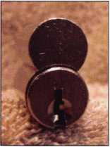

Core Specifications

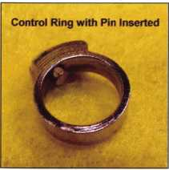

The Dominion R-Core uses 6 cham-  
bers and has a MACS of 6. The  
springs for chambers #1 through #5  
are approximately .450" in a relaxed  
state and the spring for the control  
chamber #6 is about .328" in its  
relaxed state. Notice that the spring in  
the control chamber is somewhat  
shorter in order to accommodate for  
the extended upper shear line.

The control ring increment (the distance between the operating shear line and the control shear line) is a distance of .165" or a coded 11. This measurement dictates that within the control cham­ber, the plug total must equal at least 11 in order to reach the con­trol shear line.

Core Components

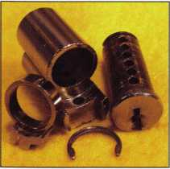

In the photo, one can see the four  
basic components of the Dominion  
LFIC: The plug, control ring, shell  
and c-clip. This core can be combinat-  
ed in one of two ways: by removing  
the plug with a conventional follower  
and then combinating, or by removing  
the spring cover and toploading pins  
and springs.

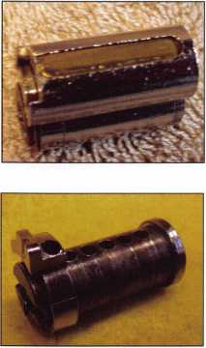

The control ring is placed over the  
rear of the plug and contains an upper  
control lug (attached) that rotates to  
allow core removal or insertion into or  
from it's IC housing. In the picture,  
you can see how the control ring fits  
over the plug toward the rear of the  
core. Notice that the control ring has  
added space for the pins to move ver-  
tically. The top of the ring creates the  
control shear line, which permits the  
ring and the plug to turn in unison so  
that the core can be inserted or with-  
drawn from its housing with the cor-  
rect control key.

Keynotes • October 2005

By viewing the two photos that show the position of the control lug, notice that when the lug is retracted so that the core can be withdrawn from its housing, the key must turn counterclockwise. Again, this is opposite BEST SFIC and Yale and Schlage Large Format, but similar to Sargent LFIC.

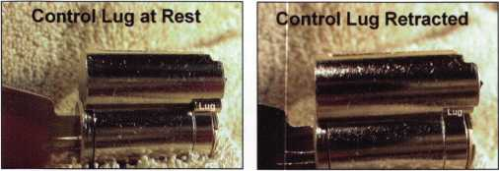

The two additional views illustrate the comparison of the control ring and lug in the "at rest" and "retracted" positions, as seen from the back side of the core.

Sample Flaws

Notice on this specific core that there are several exterior flaws. You may notice some line indentations on the bottom of the control ring, as well as on the top of the control lug. There also exists an indentation on the rear upper area of the core shell. This was due to egregious removal of the core form its housing and is not repre­sentative of a pure factory produced core.

Control Chamber

This is probably the most important chamber in the core. Why? It actuates the core’s removal or insertion. It has to be protected so that an individual with an operating key will not be able to acci­dentally or intentionally with a little manipulating remove the core from its housing.

Even though this might be moot today, care should have been taken to assure that the bittings for operating keys and control key in the last chamber are at least 3 (three) increments apart:

Parity - Not Together

An operating key of a 7 bitting in the last chamber would not be a good choice with a control bitting of 6. Notice that parity is not followed in this instance. In some situations it can, but in others it cannot. Small wear on the key might allow the individual the rare experience of pulling the core form its housing. WOW! Usually, the "core recipient" in this situation thinks he/she has "broken the lock"! But, in actuality, inadvertent core removal has occurred. A core should not be able to be released from its housing via a legiti­mately issued operating key. But, in reality, it can happen in such instances.

A Real Example

If some of us do  
encounter Dominion  
cores in an existing sys-  
tem, decoding the core  
for the control key is  
probably the most  
salient issue. Let's take  
a look at an actual core  
that was factory combi-  
nated. The photo

shows a sample core disassembled, with the pins in order on the  
pin mat. The first chamber is closest to the key and the control  
chamber #6 is nearest the bottom of the photo.

Let's take a look at this sample core as shown in Diagram #1. The  
Operating Key happens to be the TMK, with a bitting of 315933.  
The Change Key is 577355. Notice that in this example, the con-  
trol chamber is not progressed (assuming all cores in this system  
have the identical bitting in Chamber #6). Thus, the control key  
will be the TMK in all chambers, except #6 - the control chamber.

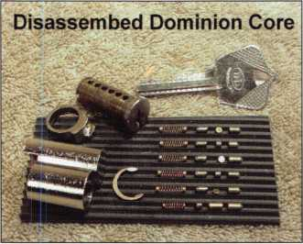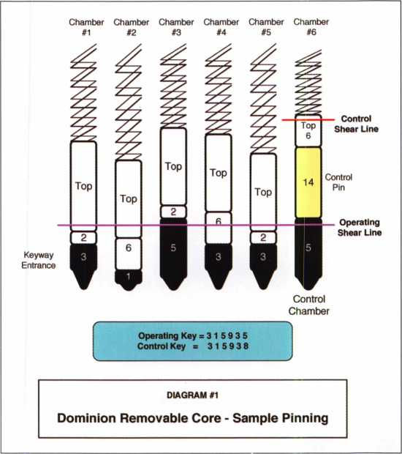

Control Chamber Formula

There are two ways to use this type of formula, based on the cir­cumstance: 1) When you have the key bitting and wish to pin the chamber and determine the control pin value, or 2) When you have the control pin depth and wish to determine the control key bitting. Since we are decoding the core and know that the control pin is 14, here is the formula to use:

Keynotes • October 2005

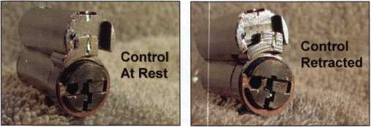

Control Key Formula

(BP + MP + CP) - 11 = CTL Key Bitting

Since the bottom pin has a value of 5 (no master pin present) and the control pin (build up pin) has a value of 14, the total is 19. Thus, 19 — 11 = 8. Eight (8) becomes the key bitting for the con­trol chamber. The control key would be created using the TMK bittings for chambers 1-5 and an 8 for chamber #6 315938.

If we knew that we had a control key cut of 8, but wanted to pin the chamber and needed to know the value of the build up pin, this would be the formula to use:

Build Up Pin Formula

(CTL Key Bitting +11) — Plug Total = CTL Key Bitting

In this case, we have the control key bitting of 8. We then add 11 to it. This gives us a value of 19. From 19 we subtract the plug total (bottom pin + master pin). This would be 19 - 5 = 14. Thus, the build up pin (control pin) would be 14.

Keep in mind that the terms "control pin" and "build up pin" are interchangeable, build up pin is used more commonly in large for­mat work, and control pin is used when working with small format cores.

Control Pinning

In the event that one needs to repin Dominion large format cores  
within a system, caution should be taken with regard to the control

chamber. In the example shown  
in Diagram #1, the control bit-  
ting of 8 was 3 steps from the  
operating key bitting of 5. If this  
distance in the control chamber  
were maintained throughout the  
system, the only other bittings  
that would be useable would be a  
1 or a 3 since the 7 and 9 are too  
close.

Diagram #2 addresses this issue  
by showing three example control

chambers—one bad, one OK and one good, if following this sys-  
tematic approach.

The Pitfalls of the Dominion Removable Core

Realizing that this particular six-pin core has five chambers that can  
be used within a two-step progression, and a sixth chamber with  
partial use (perhaps 3 bittings), one can readily see the limited bit-  
tings that would be available within a system. Not taking into  
account MACS and poor bitting combinations, the 3,072 bittings  
may work well for a very small system.

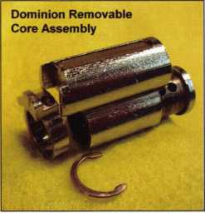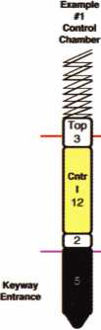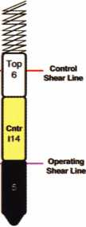

Bad OK Good

|  |  |  |  |  |
| --- | --- | --- | --- | --- |
| Top Master Key = 5 |  | Top Master Key = 5 |  | Top Master Key = 5 |
| Operating Key = 7 |  | Operating Key = 3 |  | Operating Key = 5 |
| Control Key =8 |  | Control Key =0 |  | Control Key =8 |

DIAGRAM #2

Dominion Removable Core - Control Pinning

known, all that would be necessary would be one blank! Copy cuts #1 through #5 on the key blank, leaving cut #6 as a zerobitting. Begin by testing that key. If a "no-go", make a #1 cut and try again. Repeat until the control depth is reached and the key becomes a control key.

By contrast, a BEST small format system disallows such simple decoding by the mere fact that each chamber has an independent bitting that is set as the control key bitting. Yale and Schlage make use of a longer key blank for control key use. Sargent and CorbinRusswin use more than one chamber for control activation. Medeco makes use of shallower cuts with key blank restriction for their control feature.

It becomes obvious to many that the two major downsides of the Dominion Large Format core - too few bittings, and lack of core security - were issues that helped to direct this product onto that Path of Obsolescence. Today, the Dominion Large Format Removable Core is only obtainable as a retrofit for the Kaba-ILCO 1000 Series Simplex units requiring a Dominion Key Bypass Core. However, if one should have the experience of working with a Dominion RC system, with the great variety of large format cores readily available today, selecting a replacement should not be a dif­ficult task.

|  |  |
| --- | --- |
|  | Dominion Lock Removable Core Cylinder |
|  | 201597-03-01 |
|  | 201597-05-01 |
|  | 201597-260-01 |
|  | 03 / G5/26D |

5x5x5x5x5x3 = 3,072 potential bittings

But what about larger systems? Perhaps a multiplexing would be an answer; however, Dominion was not set up with the plethora of sectional keyways such as Sargent. Corbin, Russwin or Yale systems of the past.

Another negative factor is the way that the control key could easily be created by an unauthorized individual. If the TMK bitting was

Thanks are extended to: Mitch Stover, Kaba-ILCO Key Records Manager, Mark Shellberg, Kaba- ILCO Cylinders Manger, Randy Main, Owner of Main's Lock Supply, Arnold Sintnicolaas of Toronto, Shane Maloney of Orilla, Ontario, Vince DeRose, CEO of Scorpion Lock, Montreal and John Hubei, CML of Utica, Michigan for their contributions to this article.

William M. Lynk, CRL, has been a locksmith since 1975, is an 1C Specialist, and is an industry  
author having penned Interchangeable Cores: Small Format ©2000, Removable Cores: Large  
Format ©2003 and SFIC: Advanced ©2005. He is a certified ALOA A.C.E. Instructor, teaching full-  
day classes on SFIC and LFIC at the ALOA Convention and across the country, as well as a  
member of ASIS, I LA, LSA and a Sponsor for ClearStar Security Network. Bill, the owner of ICLS  
(Interchangeable Core Lock Systems), has also originated SFIC Technical Manuals for both

domestic and international lock companies while maintaining a close working  
relationship with the major lock and security manufacturers throughout the world.

Keynotes • October 2005



Tackling An Antique Fire Door

By Eric Costley, CPL

We had just finished a large commercial job in historic  
downtown Corning, New York. Primarily, the job consisted  
of installing panic exit hardware on several pairs of doors  
during the renovation of the building. Once this was com-  
pleted, we received a call from the owner. His apartment was  
on the top floor of the building, and he wanted us to put a

lock on the entry  
door.

The door that goes  
to the apartment  
from the stairs  
turned out to be the  
original door: a  
huge, thick fire door  
manufactured by  
Weirton Steel. I  
don't think that I  
had ever seen any-  
thing like it! (Since  
then, I have seen  
several more in the  
area.) The door itself  
was 2 3/8 inches  
thick. The latching  
mechanism on the  
exterior of the door  
consisted of thick steel  
boltworks which  
made it resemble a  
vault door. I took  
some measurements,  
and decided that there  
was virtually no way  
to install a regular  
deadbolt. At 2 3/8, 2  
3/4, or even a 5 inch  
backset, there was  
going to be interfer-

ence with the latching boltworks. (In addition, I don't think  
that anyone manufactures a 5 inch backset for a deadbolt  
anymore. We special ordered a Schlage bolt for a B160

recently, and our distributor informed us that they had one, but it was no longer being manufactured.) I left the site with a perplexed look, and told our customer that I would have to do some research. He called several times a week to make sure I hadn't forgotten him.

One of the nice things about the locksmith business is that as time goes on, you find that different aspects of the profes­sion all blend together and overlap. In other words, what you observe or learn at one job may well help you out later in a seemingly unrelated matter. It is important to take the time to step back from a problem job and think. Sometimes, a little break gives your brain time to process things by itself, and the solution suddenly becomes apparent.

I was on a simple lockout about two weeks later in a neigh­boring town, and noticed another one of these monstrous doors. To my surprise, it had a mortise lock installed! The cylinder was partially eclipsed by the steel bands that operat­ed the latch, so I assumed that it had been installed when the door was manufactured. I immediately knew my plan of attack.

I had been distracted by both the size and thickness of the door. With a mortise lock, all that is required to conquer the thickness of the door is cylinders of the appropriate length. I returned to the door once more to check my theory, and decided that a regular storefront mortise lock in a 1 ? inch backset would work nicely. I ordered the parts, and set aside half a day to tackle the job.

I knew that the outer skin of the door was a thin layer of steel, but I had no idea what to expect once I got below that. I had a sinking feeling that was waking me up at night, anticipating either concrete or asbestos. Neither of these options thrilled me. As it turns out, the interior structure of the door was tongue-in-groove boards. (The contractor who had initially straightened out the door so that it would close properly had to shave the bottom of it. If I had known this earlier, I might've slept better!) Once I had chiseled out the skin of the door, I knew this part of the job would be a breeze. I used a 3/4 inch holesaw to hack out the cavity for the lock, and a chisel to smooth it out.

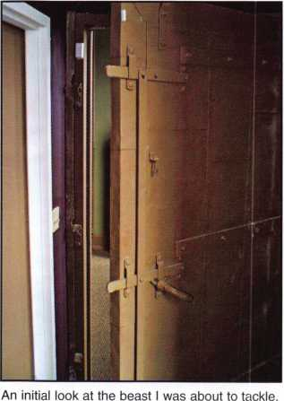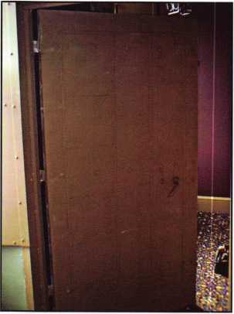

Here's a look at the interior side of the door.

**16**

Keynotes • October 2005

The installation of the lock went smoothly. You might notice from the photos that the faceplate of the lock is recessed a bit into the edge of the door. This was inten­tional, as the stop on the frame of this beast was a 3/4 inch chunk of solid steel. I wanted to make sure that I had plenty of clearance for my thumb-turn cylinder, because I had no intention of trying to carve a hunk out of that! Once the lock was installed in the door, it was time to start on the strike hole.

My choice of a store front deadbolt, (such as you normally see in a glass and aluminum door,) was carefully thought out. Most mortise locks have brass or bronze parts, and sometimes cast cases. I wanted something that would stand up to some serious abuse if necessary, and the size and weight of the door made me think that a good steel bolt would be the best choice. The only glitch in this deci­sion is that the strike hole must be larger to accommodate the swing of the bolt. The entire frame of this door con­sists of 1/4 inch plate steel, so I knew that the fun was just beginning. I marked the frame, and started drilling small holes around the perimeter of my marking. After I had a nice rectangular row of holes, I started leaning the drill up and down to widen them out and "connect the dots". A chisel managed to take the remaining chunk out, and after that it was simply a manner of adjusting the alignment and cleaning up the hole so it looked "pretty".

I did a lot of sweating and cursing as I cut through the frame. I took a LOT of breaks, and was getting pretty dis­couraged.... and then Mark showed up with the recipro­cating saw. (Whew!) As you can see, our finished strike hole is not as aesthetically pleasing as we might wish, but after spending several hours and a great deal of perspira­tion, we were satisfied that the lock worked properly. After all, the job entailed a lot more than most, and we were sim­ply happy that the strike hole had no rough edges or burrs that might cause a little cut or scrape.

It's not every day that you run into a job like this, and my primary reason for this article is to remind us all not to be overwhelmed by something unusual. It's important to let the customer know that what they want is "off the beaten path", and that time and research is required. I've been known to tell customers that I would have to sleep on it, and get back to them. (Once again, sometimes the brain works best when undisturbed by your initial panic!) When

Using the hole saw, I started cutting out the cavity for the mortise lock.

A view of the steel skin hacked away to reveal the pleasant surprise: a wooden interior!

The majority of the time spent on this job was cutting through this 1/4 inch steel frame.

faced with a strange task, take your time and use your expe­rience and wide array of knowledge and resources to slowly filter down a viable resolution. In the end, you can walk away with the feeling of a job well done, and a feather in your cap.

Once you have a few of these unique jobs under your belt, word will spread, and you'll develop a reputation as a prob­lem solver... and that inevitably translates to future work.

Keynotes • October 2005

**17**

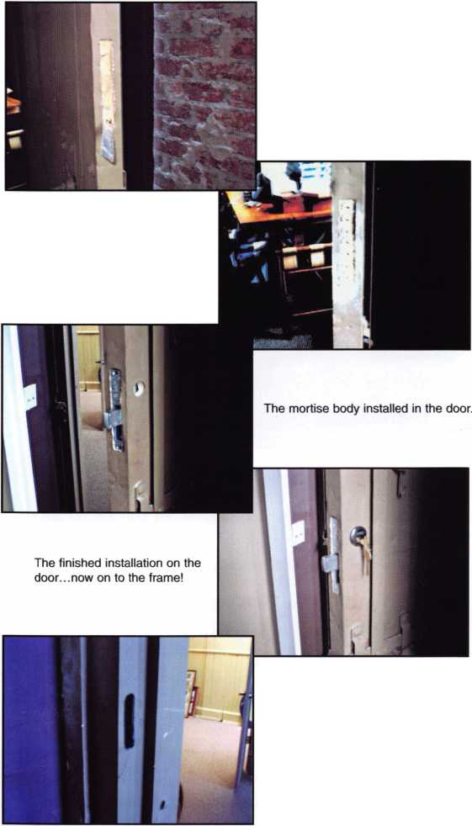

Making the Switch

By Greg Perry, CML, CPS

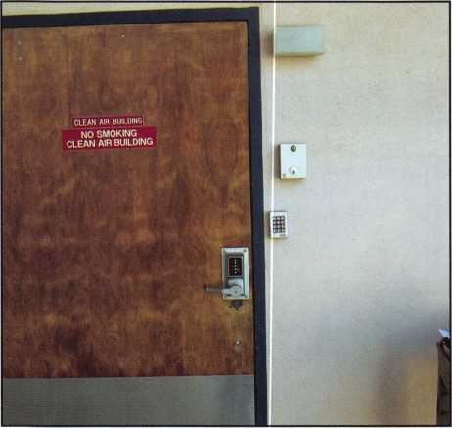

i

Switching can be difficult, there is a degree of uncertainty with new products and we like what is familiar. We typically do not like to change brands of locks or style of work. The old adage “If it ain’t broken, don’t fix it” applies.

About four years ago I saw Alan Oblath, currently the Western Regional Sales Manager for Marks locks at a convention. He tried to convince me to change to the Marks IQ line of locks. During the demonstration, I noticed a benefit to switching. The Marks design would solve a problem I was having with a keyless mechanical combination lock. (I should note the IQ lock is a stand-alone electronic lock.) The problem with the lock involved the inside lever. The design of the lock did not allow upward turning of the lever. If I tried to turn the lock upward, it broke.

A particularly troublesome installation involved a hospital emer­gency room. The door was located at the end of a hallway. The door opens in and was approached from latch edge. The natural tendency for entry would be to lift up as a person reached the door because pushing down require the person opening the door to move further toward the hinges. Although the hospital personal operated the lock properly, the patients would pull or lift the lever to open the door and the lock failed every couple of months.

Marks designed their lock to allow the inside lever to turn either direction without problem. I tried a Marks IQ1K cylindrical, it worked so well that I made the switch. The lock worked smooth­ly, more importantly the customer was happy. Since that time I

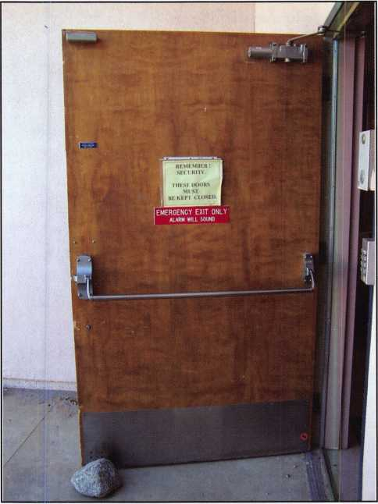

2

have stopped stocking keyless mechanical locks and have replaced them with the Marks IQ line. This article is going to take you through the switch to a Marks IQ7K lock mated to a Von Duprin 88 rim device.

Photos 1 and 2 show the door with the old lock and the Von Duprin 88 exit device installed. The old lock has a history of tail­piece breakage. The door is near the nursery, so it must stay secured. Next to the door is a Detex door alarm with an IEI key­pad to shunt the door alarm as it is opened. When the tailpiece broke, a second employee was always called to open the door from the inside. This time, I wanted to change the lock before it broke again.

After removing the existing hardware we found lots of existing holes in the wood door. These holes can be seen in photo 3. This door originally had a thumb-piece trim with a rim cylinder. The lower thumb piece hole was covered by a Donjo hole filler. I removed it. Placing the Marks IQ7K up to the door I found many more uncovered holes. It was time to resort to an “old standby” repair which involved using chrome-plated brass push

**8**

Keynotes • October 2005

plates. (I stock both brass and chrome-plated push plates for cover-ups. I try to stay away from aluminum plates because they offer very little strength. I don’t stock stainless plates because it can be difficult to drill large holes through them.

Looking at the existing holes in the door and the IQ7K, I posi­tioned the plates to offer the best coverage. The inside and out­side plates offset each other on the door. Using the templates provided (as seen in photo 4) with the IQ7K, I predrilled all the holes into the push plates. Next, I aligned the inside plate with the existing holes for the exit device and mounted the device to the door (photo 5). I then reinstalled the two lower sex bolts for mounting the Von Duprin 88 device. This was done because the Marks inner plate does not have tapped holes or provide any sort of insert nut in the plates.

I was then ready to drill the upper three holes required for the IQ7K mounting using the inside metal push plate as a template. Once the holes were drilled, I aligned the outer plate to the holes. I then used a drill bit as a guide in one hole to align the predrilled outer plate. Next, I double-checked the alignment using a tape measure. The measurement was off! “It can’t be my fault!”, I thought and realized that David, my co-worker, must have allowed me to drift as I drilled the hole. Correcting David’s mistake involved re-drilling the hole and wiggling the bit. Once we corrected his mistake (it’s never my fault) we clamped the plates to the door, checked alignment and used the holes in the push plates to drill the two 2 1/8” holes for the outside trim. As is standard, the upper hole was only drilled 1/2” deep on this wood door as this is the area for the mortise cylinder of the key override. On the opposite side of the door were two upper mounting screw holes for the exit device. Photos 6 and 7 show the plates clamped to the door. (A quick note: the outside plate was originally drilled for a Kaba Ilco 1000 series lock. There are three extra holes in the plate that were not needed for this instal­lation between the upper 2 1/8” hole and the raceway hole for the IQ7 lock.)

Next, we installed the outside lever on the IQ7K. This lock is not handed until the lever is installed so it can be changed to the other hand at a later time. This feature allows the lever to operate by turning either up or down. Marks designed this lever to be free or clutch going up or down until the correct code is entered or until the key override is used.

The lever was placed on the spindle and a socket head cap screw was installed from the inside through the spindle hole. The mor­tise cylinder was installed between the spindle and the wire race­way. Turning the mortise cylinder engages the lever to allow it to turn and open the door. The spindle (seen in photo 9) was then

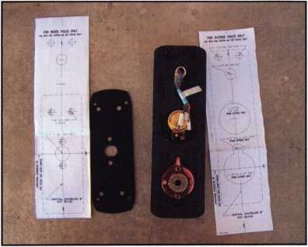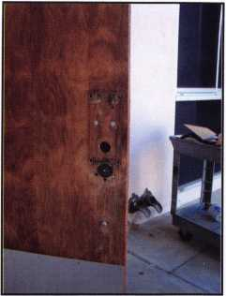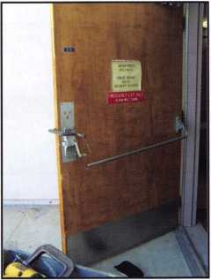

installed with a spring between  
the underside of the lever  
mount and the spindle. The  
spindle design is strong. It is  
based on a square mortise lock  
spindle with both ends  
machined-one for the spring  
and the other made to the size  
of a rim cylinder tailpiece.  
Since it is square, the spindle  
can be installed with the flat

either hori-  
zontal or  
vertical, as  
needed.

Once it was  
fully assem-  
bled, we  
placed it on  
the door  
and

attached  
with it with  
the four  
screws

through the push plates and  
the inside Marks mounting  
plate. I like this design as I was  
not forced to try and position  
the outside and inside device  
all at the same time.

Earlier, I mentioned recessing  
and reinstalling the sex bolts in  
the two lower screw holes.

After installing the IQ7K, we  
found a small problem. One of  
the two sex bolts would not  
line up. Rather than take  
everything apart, we opted to  
drill the hole and install a nut-  
sert or trik-nut. We had  
planned to use them in the  
upper two mounting holes so  
using one more was not a big  
deal. You can see all three nut-  
serts in photo 10. I’ve spoken  
with John at Marks about the  
mounting plate. Their original

6



Keynotes • October 2005

*mm*

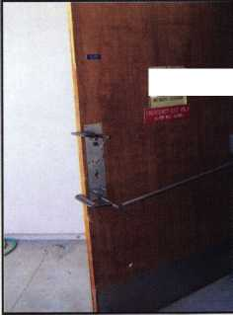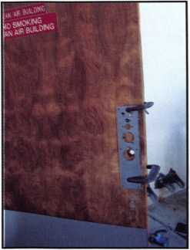

intent was for new installations. This would  
allow for the device to be mounted with fresh  
holes in either wood or metal doors. Retrofit  
applications, especially with sex bolts already  
installed, will require using a nut-sert in the  
upper two holes of the adapter plate. The  
■upper two holes are in line with the cutout in  
the outside of the door for the mortise cylin-  
der. There was no chance of reinstalling sex  
bolts for these two. Nut-serts are the best  
method at this time unless Marks changes the  
plate to threaded holes for mounting the

device. The lower two holes are below the bot-  
tom of the IQ7K on the outside, so unless you  
install push plates or some other cover up you  
will need to reuse the sex bolts. The complet-  
ed install can be seen in photos 11 and 12.  
This was a fun install; it required a little more  
skill than a standard install.

Finally, the IQ7K is a standard rim cylinder  
replacement for use with a variety of exit  
devices. Currently, they list seven in their liter-  
ature. The 88 is a new plate so it is not listed.

If you are installing it  
with a Von Duprin 88  
you need to order a spe-  
cial version. The 88  
device requires a little  
more turning to fully  
retract the latch. The  
modification to the

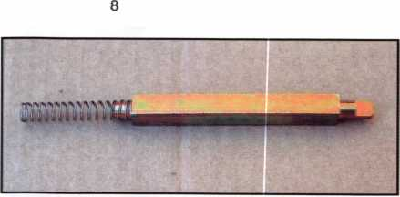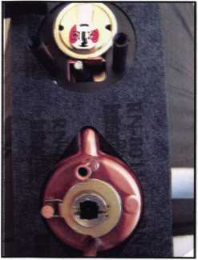

9

IQ7K adds $100.00 to the approximate $700 list price. Also, you will need to order the appropriate inside adapter plate for use with your exit device. Hopefully Marks will redesign the 88 adapter plate for friendlier retrofits either by adding nut-serts or tapping the plate.

Programming these locks is pretty simply via the keypad or the locks may be programmed with the I-dat upload/download device. This is an interface used so that the full benefit of the locks programming and audit trial can be uti­lized with software on a computer. The basic unit will allow up to 320 users and a 1600- event history log. This feature can be upgraded on the door should your needs change in the future.

This article covered the installation of the IQ7K. Marks produces cylindrical, tubular, mortise and keypad-only versions. In addition, they offer the same styles in a proximity reader version and two different styles of keypads. More information can be found at marksusa.com or by calling 800 326-0233.

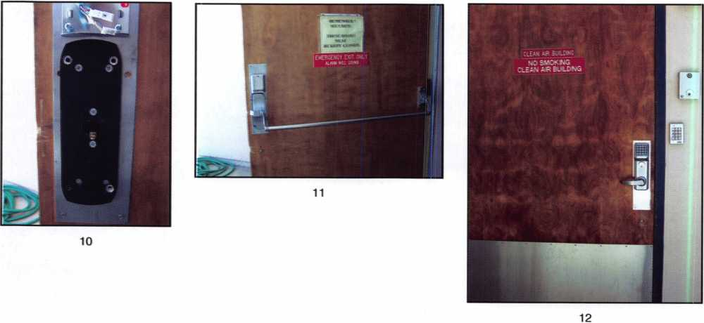

**20**

Keynotes • October 2005

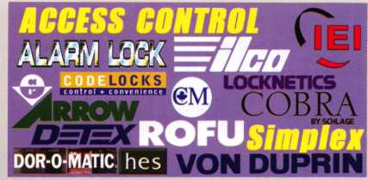

**WEISER LOCK**

**Scf<r Td Co**

*AUTOMOTIVE ' Jet*

**" »»«*« LOCKBRAFT^**

@ASP HATA „ JZ,

***DETERMINATOR MAJOR (person***

♦

c **PRO-LDK**

STECK Hted^eco-*

**CAL-ROYAL**

ITOMM

jadcson

*TOOIS*

*t ***DIMM II***

A A'oi-I;

0AS P)

**AVENGER**

**BOXER**

jr;

**LOOKERAFT^**

**lOCK jECHIMOLOGY**

*MAJOR*

PRD-LOK

*i/tCLTL*

{^LPCKwth roots wBLiLSsyLSr

L

|T*£

**" «W«U - ■ owimu.'.i**

***Why Do*** *Locksmiths* ***Everywhere Buy Supplies at***

***H.L.Flake?***

***H* Extremely Competitive***

***E/Z Free Freight Minimums***

KJ U 111 V

***Service with a Smile  
High Fill Rate  
Hard to Find Items***

***Jc E/Z Order Web Site***

*WWW*. *HiriAKE. com*

* *Order 24 hours a day*
* *Updated Every Business Day*
* *Extra Discount for Web Orders*
* *Personalized Inventory Lists*

*LOG ON TO*...

WWW. HU LAKE, com

WON) IQQQO

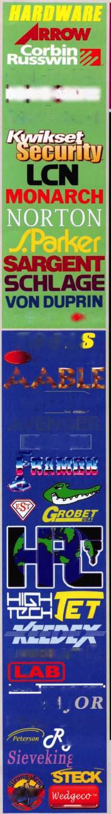

A-2 Brutus? Small Format Interchangeable Core (SFIC) Made... Bearable (Part 2)

By Jim Hancock

Last month we discussed terminology, the cylinder, depths and spac­ing, key cutting, tools, this month we will deal with the math and techniques for control pinning and core removal.

THE MATH

illustration 1

A2 Stack Diagram

Chamber

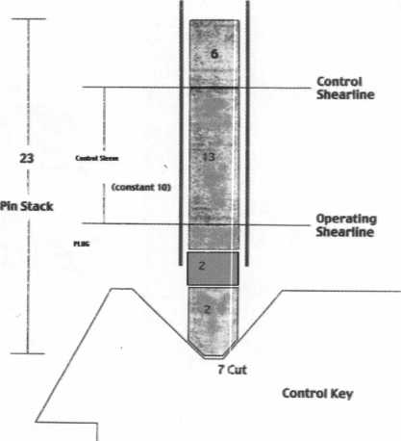

Okay, before you ask for a hall pass so you can skip math class, let us see if we can simplify the mathematics of SFIC.

As with any pin tumbler lock, it all starts with creating a shear line at the top of the plug to allow the lock to turn. SFIC is no different. If the operating key is cut to a bitting of 26871 5 9 and there are no master keys involved, you simply drop the corresponding pins into the chambers and the plug will indeed turn with the operating key. If there is a master key being used, the pinning would again be the same as a standard pin tumbler lock.

Master Key: 4 8 2 1 5 9 3

Operating Key: 2 6 8 7 1 5 9

Bottom Pins 2 6 2 1 1 5 3

Master Pins 2 2 6 6 4 4 6

So far so good, right? But we still have to deal with the control key

Without this key we can not move the lug to remove or insert the cylinder into the housing. In order to accommo­date the control key we must create a shear line at the con­trol sleeve which will lock the plug and sleeve together allowing the lug to move. In order to do this, we must “build up” the pin stack from the operating shear line to the control sleeve shear line. This is done by adding the width of the sleeve where the control lug and pin chambers for the control lug are. If you recall earlier we said the sleeve was .125” thick at this point. If you look at the increments of the pins in an A2 system, this is the same thickness as a #10 top pin. Rather than use decimals we will use whole num­bers to figure our control pins.

First, let us start with a control key We will use 7 3 1 3 8 2 8 as our bitting. This would be the bottom pin that would create a shear line at the plug. What we will do is add the sleeve dimension (.125”) divided by the increment of .0125 which gives us a control dimension of 10 to this bitting (on paper only you would cut the key as normal). So for pin­ning math purposes, the control number would look like:

17 13 11 13 18 12 18

This would now be the bottom pin you would use to reach the root of the cut to the top of the sleeve to create the shear line. But not so fast. We already have bottom pins and mas­ter pins in the lock, right? So what we need to do is subtract the total pin stack already in the lock from the control num­ber and this will give us the size of “control pin” to use to create the control lug shear line as follows:

Master Key: 4 8 2 1 5 9 3

Operating Key: 2 6 8 7 1 5 9

**22**

Keynotes • October 2005

**Bottom Pins:**

2 6 2

**Master Pins:**

2 2 6

**Pin Stack:**

**4 8 8**

**Control Number: 17 13 11**

**115 3**

1. **4 4 6**
2. **5 9 9**

**13 18 12 18**

(minus)

Pin Stack:

4 8 8 7 5 9 9

equals

Control Pins:

13 5 3 6 13 3 9

What we now would have in each chamber would look like this:

Bottom Pins:

2 6 2 1 1 5 3

Master Pins:

2 2 6 6 4 4 6

Control Pins:

13 5 3 6 13 3 9

At this point, both the operating key and the master key would create a shear line at the plug allowing the lock to operate while the control key would create a shear line at the sleeve, allowing the lug to be retracted for removal or inser­tion. The last thing we need to do is provide top pins and springs. Is there a formula for this as well? Certainly! In order for the lock to operate properly the springs must hold proper tension on the pin stacks and the top pins must block the shear line when no key is inserted. Also, we must not over­stack the chambers by using a driver too long because the key will not go in the lock if this happens. So, all this being said, the A2 system takes all of these factors into account and using the dimensions of the SFIC itself, a dimension is estab­lished that will accommodate all of these elements this dimension is called the Pin Stack Height or Pin Stack. If we use whole numbers rather than decimals, the total pin stack height must equal 23; no more, no less. So, in order to put in the proper top pins, we will add the total of the pins are

currently exists in each chamber and subtract from 23. This will tell us what size top pin to put in each chamber.

Bottom Pins:

2 6 2

Master Pins:

2 2 6

Control Pins:

13 5 3

Total Stack:

17 13 11

115 3

6 4 4 6

6 13 3 9

13 18 12 18

Now subtract this number from our pin stack height:

Pin Stack Height:

|  |  |  |  |  |  |
| --- | --- | --- | --- | --- | --- |
| 23 23 | 23 | 23 | 23 | 23 | 23 |
| Total Stack:  17 13 | 11 | 13 | 18 | 12 | 18 |
| Top Pin Size:  6 10 | 12 | 10 | 5 | 11 | 5 |
| Each chamber would | | now look like this: | |  |  |
| Bottom Pins:  2 6 | 2 | i | 1 | 5 | 3 |
| Master Pins:  2 2 | 6 | 6 | 4 | 4 | 6 |
| Control Pins:  13 5 | 3 | 6 | 13 | 3 | 9 |
| Top Pins:  6 10 | 12 | 10 | 5 | 11 | 5 |

If you load your SFIC from tip to bow using the pins your math has given you load the springs and cap the chambers, the Operating Key, Master Key and Control Key will all operate in the manner they are designed to.

CORE REMOVAL WITHOUT A CONTROL KEY

Many times in your career you will be called upon by cus­tomers to rekey a SFIC when there is no control key avail­able. When this occurs, you must remove the core in some manner that is the least destructive to the lock housing. If you are dealing with a single core, drilling the lug would possibly be the easiest and most efficient method. This is

**23**

Keynotes • October 2005

accomplished by using a 1 /8th inch drill bit on the left side of the core where the upper and lower cutout of the housing meet, (if viewed as a figure “8”, it is where the 2 circles cross to form the 8). This will remove the lug and allow you to pull the cylinder. However you must be cau­tious not to let the drill bit drift and damage the housing.

So, why not impression or pick the lock? Think about the construction of the SFIC for a moment. You are dealing with 2 physical shear line locations. If you are attempting to impression, when you put turning pressure on the key, the binding of the pins is occurring at 2 locations. When you get marks for impressioning, there is no way to know which shear line is creating the marks. You may very well file a key that shears at various points along the 2 shear lines which will not allow it to either open nor release the lug.

Picking? Same principle applies. There is however a small advantage that can be used when picking. If you look at the bottom of a SFIC, you will see small holes. These are there to facilitate the use of a pin ejector tool that removes the pins and springs for rekeying. This means that these holes go through the shell, sleeve bottom and plug bottom. Because of this, if we use a specially designed tension

**1-Core Turning Tool**

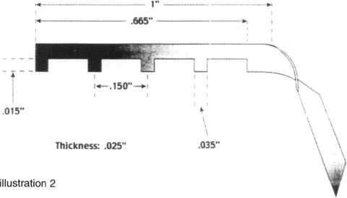

wrench (see illustration 2) which is notched using the cen­ter to center spacing of the plug, these protrusions between notches will lock into the holes, binding the plug and sleeve together (without protruding through the sleeve into the shell). Now when we attempt to pick the lock, our ten­sion will be on the sleeve shear line. This still will not be easy because the tolerances of the lock are pretty tight, but

your odds have certainly increased.

*Mil Point for* Removing Cap Shimming

If you have multiple cylinders to rekey, without a control  
key, this could be a real chore if you are left to picking  
each or costly if you are drilling each. Here again there is a  
short cut which will destroy one core but allow you to  
decode the control key to easily remove the remaining  
cores. If you

look closely at illustration 3

a SFIC, (see  
illustration 3)  
you will see  
that the face  
on the front of  
the upper shell  
is a cap. This  
upper face is  
the portion  
that would  
have BEST or  
FALCON  
stamped on it  
if it were one

of these brands. This cap is held on by a blind rivet or  
mushroom plug. The cap is placed on the front of the  
cylinder and using pressure is pressed on. The pressure  
makes the rivet or plug spread into a recess and holds the  
cap in place. Using a 1/8” drill bit approximately at the  
center of the cap (between the E and S on Best or L and C  
on Falcon) drilling inward again approximately 1/16” will  
almost destroy the mushroom. A small screwdriver can be  
used at the edge of the cap and by prying outward the cap  
will pop off. When this happens, the sleeve lying under-  
neath is exposed (see illustration 4). Using a standard shim  
inserted between the sleeve top and the shell and a pick,  
you can shim the pins from front to back creating a shear  
line. You then would be able to use a small punch or  
screwdriver to push clockwise on the sleeve which will  
retract the lug allowing removal.

With the SFIC removed, carefully remove each pin stack  
from each chamber being careful to keep the stacks in  
order from top pin to bottom pin. With stacks laid out,  
measure the top pins with a micrometer and convert the  
reading to the whole number that corresponds in your pin  
kit. In other words, using our example from above if we

**24**

Keynotes • October 2005

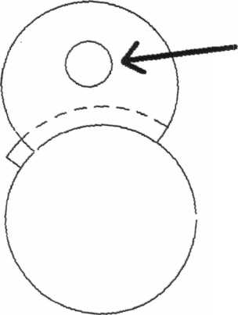

illustration 4

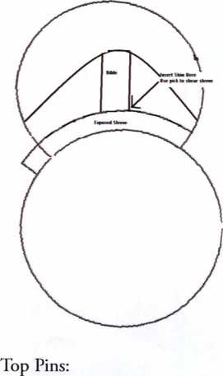

6 10 12 10 Subtracted from 13 = Control Key Bitting:

7 3 13

measured the top pin in the first chamber, it would read .075 which

i ani imi cap

would equate to a #6 top pin. Once this is complete for all chambers we then would subtract these whole numbers from 13 to obtain our control key bitting:

5 11 5

8 2 8

Amazing! This is the control key we had in our example. But why 13?

Well, the total stack is 23. The control dimension was... 10.

Meaning everything else other than the control totals 13. If  
we subtract the top pin from that number, it tells us what is  
needed to create that shear line at 10. You have destroyed  
one core and created a control key to remove the rest. How  
cool is that!?

FINAL THOUGHTS

This is by far oversimplified. SFIC work can be much more  
difficult and complicated. As with any other lock, for every  
one that works this easily, 5 more will drive you crazy. And  
this article is certainly not designed to replace good hands on  
instruction from some of the masters in our industry such as  
William Lynk and Randy Main. I would be remiss if I didn’t  
mention the late A J Hoffman and Gerry Finch whose  
knowledge on this subject is known throughout the industry.  
But this article is designed to give you a base to work from  
and hopefully a little more understanding and less fear of  
these profitable little jewels.

Now, about the Titanic and Lucky Line. You see, while  
Leonardo was locked below deck...

Visit our website at [www.aloa.org/A2](http://www.aloa.org/A2) for corresponding Pinning Charts.



ALOA is working hard  
to help those whose  
lives have been affected  
by Hurricane Katrina.  
Visit our website today  
to see how you can be  
a part of this effort.  
[www.aloa.org/katrina](http://www.aloa.org/katrina)

Keynotes • October 2005

**25**

Who Knew the

Special Talents of a Locksmith?

By Jon B. Griswold, CML

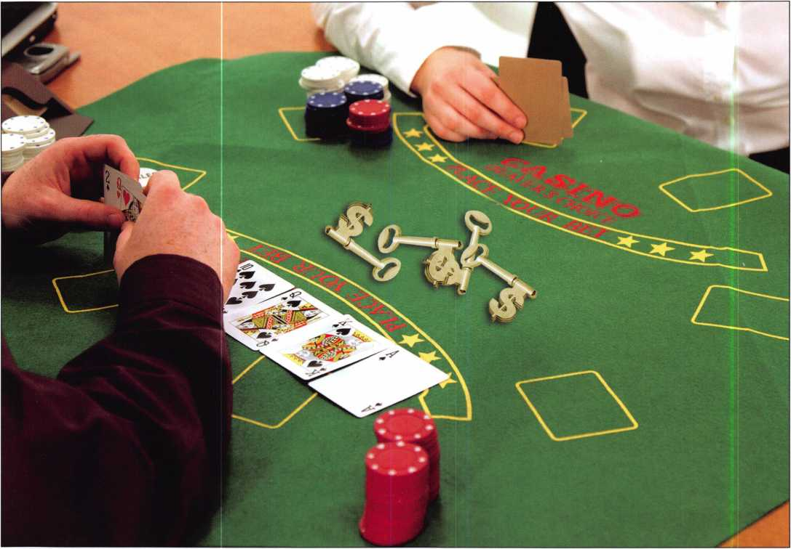

After 25 years as a locksmith, I’m amazed at how much I’ve learned. I dreamed of other professions in which a locksmiths talents would work well. After careful research, mostly daydream­ing and watching TV, IVe come up with the following Top 5.

High Stakes Poker Player

Like everyone else, I have a fascination of high stakes poker. But when my friends tell me how “cool” it is when the players pick up just the right number of chips or roll the chip in their fingers. Heck, I’ve been doing that for years! I just use keys. If a customer needs 3, 6, or 10 copies, its no problem. I just grab the stack,

and pull off the right number off the hook or out of the box. I’ve watched some of the more animated players flipping a couple of chips into the pot. Big deal. I can flip keys on the counter, off the register, and within inches of the pen I threw for the cus­tomer to sign the invoice. Learning how to keep a straight face and not let the other players know what you are thinking is another handy poker skill. That’s just too easy. Has a poker play­er ever had a customer come up to the counter and ask if you make keys? How about when they come in and ask for the mas­ter key because they lost their key and need to get in? Maybe I should set up some cameras in the shop and see if the Discovery Channel is interested.

**26**

Keynotes • October 2005

Inventor

I have learned how to use so many tools in so many ways. I see all these ads for multi purpose tools that can do everything, but I’m not very impressed. I still have the first multi=use tool IVe had since I got into locksmithing. It can be used as a chisel, hammer, screw remover, punch, pry bar, scribe and, if held at the right angle, it can be used as a box cutter. Some people refer to it as a screwdriver. These are the same people who have hundreds of tools in their tool box when all they really need is a handful. I’m able to hold a tool in each hand and a flashlight in my mouth. Now, I see some wimp has “invented” a light that can be held in your mouth while working. Heck, it even conforms to the shape of your mouth. No wonder our society has gone soft, there’s no reason to rough it anymore or to use your imagination.

NASCAR Driver

Locksmithing has allowed me to become so proficient at driving that I don’t even use hands much anymore. Eating fast food, drinking soda, using the phone and reading a map have just become easy for me. I keep looking for more excitement. Now I’ve found that I can eat soup and remain in my lane. And I don’t mean just drink it, or wait until I am at a light. I mean that I actually eat soup with a spoon while driving at the same time I am using the phone, taking a message, reading the map, and checking the time). The guys at NASCAR only have to drive around a track in a circle. Big deal. Especially when you have a crew chief and full staff helping you out. These guys have never seen me weave in and out of traffic, barely missing the car in front of me. Now have they seen how well I can pull out of a traffic pack to make a quick turn without spilling one drop of my soda. Now, that’s a talent!

Determining just how far I can drive after the “needs gas” light comes on is another special driving skill. Each pit stop becomes more exciting than the last. The last time it happened, I coasted right up to the bay, landing directly in front of the pump. I know those NASCAR guys could win more races if only they would use my calculations for gas mileage during the race. If I was 20 years young, I would try the racing thing. But just imag­ine what the car would look like. I imagine keys and locksmith logos all over with the ALOA logo on the doors.

Undercover Operative

I wonder how many people can walk through a mall and identify every piece of hardware on the stores. I can tell you the make,

model, finish, backset, style, and keyway with a quick glance. This would probably translate into high excitement and adven­ture as a covert operative. Imagine a locksmith watching the night sky for intruders or the waters for enemy boats. With a simple glance, we could tell the type of plane or boat, the color, note any insignias, and identify the country it came from. We could even specialize in coded messages, both written and verbal. The way we decipher our own, other locksmiths’, and our cus­tomers’ handwriting would make this a natural. Some of the writings we deal with make a doctor’s orders seem elegant. And because we can decode what the customer is really asking for, we could probably be certified as an instructor for this specialty. For example, sometimes a customer will ask me for a price on an auto key. I instinctively know that this means the customer has no key at all. There have been many times that a customer will say they are “just down the street”, which really means they are 30 miles away (as the crow flies).Enemy agents could never understand these coded messages. Plus, we already experience going into dark dangerous places at night and eating cold food or worse. I know what you’re thinking: bad neighborhoods. No, I’m talking about returning home late at night after telling your wife you will only be gone an hour. Now, that’s dangerous!

Attorney

I am using the word attorney because there isn’t a professional called “complainer” or “arguer”. Anyone who has attended a locksmith meetings knows what I mean by this. You know the old joke: “Put 10 locksmiths in a room and together no 2 can agree on the time of day.” Could you see one of us in a court­room? There could only be 3 possible outcomes. First, because of constant training in the art of verbal conflict, we could come up with a valid point and win. Second, we have a tendency to beat the point to death so that the opposition conceded just so we’ll stop. Third, and most likely, the judge would rule against us and we would tell him he doesn’t know what he is talking about. And because we will argue to the end of the world, the judge would simply hold us in contempt and send us to jail. No problem! With our skills, we could just simply open the jail door and con­tinue the argument. Okay, maybe it’s not a **good** idea but I do love the way an attorney gets to charge the client even when they lose a case. Can you imagine?

Maybe I’ll just keep my day job. What other job can offer all the challenges, stress, long hours, low pay, thankless customers, cold dinners, and a constant need to upgrade tools and software?

None that I can think of.

**27**

Keynotes • October 2005

20 Years of ALOA Golf

Here’s to Twenty-FORE! More

? tl**fM**Bament will be $150 ^ s transportation to and MLnd breakfast, official **^Kat,** 18 **V^y,** if golf w delivc onally to

pge cart **^^jZ^s^ening** baf y even ^VHlHBj^nce to d< - Duttiif Hf in our cv

Golf Classic Committee, tioipation in our tourna s year’s event* Becaus Scholarship Fund has r, ’s event is in full a nout this year ffY **f**

ard to thi^v ourth Ar­

es f ^ . Thi golfing ch

| gp|| **Yale**

**|!flfuA Open** ^l^^thei r more money to have them as

This year’s event « Security Products, will use their name sponsorship, we have V the scholarship f und.^K our sponsor again thisW

to

The entry **te** year* This course, ori **<** Open golf **%** prizes, re% course by ov fe11owship golf str^’ 1 f i 1 ra­the

ALOA

if ts,

your

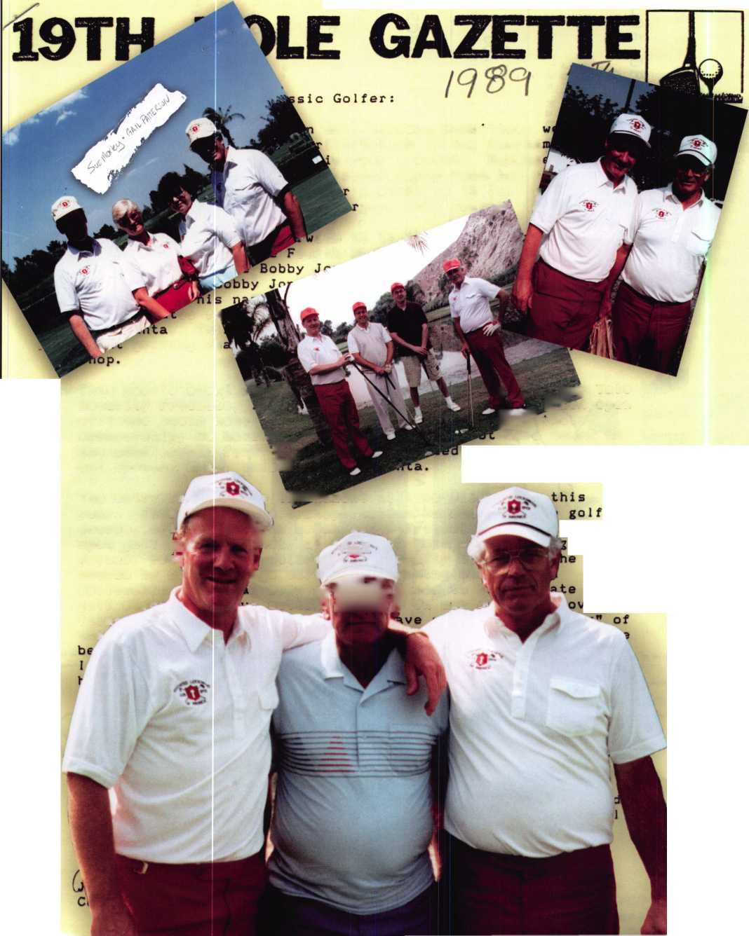

This year at the ALOA 2005 Convention and Security Expo, Reginald Moxley, Chairman of the ALOA Open, and John Patterson, Co-Chairman, thanked their team (Mark Hokenson, Les Matthews, Bob Henke, John Hubbard, and Frank Hartung) for another great ASF Golf Tournament as they retired and passed the torch to a talented new group of leaders and organizers.

Since its inception twenty years ago, the golf tournament has raised over $250,000.00 to educate locksmiths in the field. This year, when announcing the 2005 winners Moxley stated, “The students who are able to take classes via the ALOA Scholarship Foundation are the real winners.”

In a recent interview for KeynoteSy Reg Moxley and John Patterson shared the rich history of the tournament.

Both men had served on the ALOA Board for 12 and 8 years respectively. At the conclusion of the 1985 ALOA Convention and Security Expo, they decided they wanted to volunteer for ALOA in a fun new way.

At a little watering hole with their wives, the men discussed the future. They both liked golf, but never had time to play at ALOA events. Therefore, it was decided that an ALOA-spon- sored golf outing during conventions might be just the thing.

During that time, the ALOA Scholarship Foundation was in if s infancy. Unfortunately, they had no funding. Their best method of soliciting donations was to shake a coffee can in front of the convention attendees and pray for a miracle. The method was not only annoying to members who were consistently bombard­ed with requests for loose change during class breaks and lunch­eons, but did not bring in the funds needed to purchase scholar­ships for worthy students.

The answer was clear. The ALOA Open Golf tournament would support the industry by supporting the ALOA Scholarship Foundation.

With the input of another long-time member, Les Matthews, the groundwork was laid for the type of tournament they wanted.

The next problem the men faced was financing. The last thing they wanted to do was ask the ALOA Board for money. They kicked around some different ideas, but realized that this project needed some serious thought. They talked to a few of the Board members and the new president, Joe Jackman, and they were all in favor of an annual golf tournament, but no one talked about finances.

About two weeks later, Joe called and asked Reg to cover the Fall Education Meeting in Washington D.C. as an advisory. It was at that point that Reg suggested checking out local golf courses to see what was available for the 1986 ALOA Open. After a couple of days of searching, he found a cow-pasture golf course with just the right price. Reg returned home and reported to John what he had discovered and the two men decided to loan the ALOA Open Golf Classic $1500 to get started. Providing start­

up funds for the project gave them the money to buy hats and shirts for the first tournament.

At that time, the men established the entry fee of $150 per player, thinking that they could easily break even. Each partici­pant got a hat, shirt, golf balls, tees and markers. Also included in the package was breakfast, green fees, cart, cocktail party, din­ner and everyone received at least one prize. For the first two years, Les Matthews procured enough prizes for all of the players. He was able to get donations of items like golf balls, shirts, visors and many other gifts that made the first two tournaments very successful. When the smoke cleared after the very first ALOA Open, the committee proudly donated $1000 to the ALOA Scholarship Foundation.

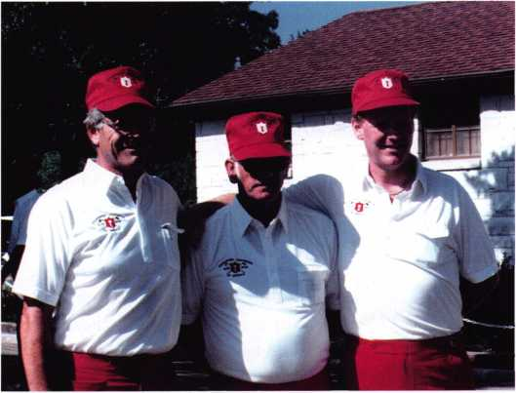

Founders of the ALOA Open Golf Classic • Dallas, Texas  
Stevens Park Golf Course  
L-R: Reg Moxley, Les Matthews, John Patterson

Thinking they were pros at running golf tournaments by 1987, the committee went to Stevens Park Golf Course in Dallas. Although the course conditions were not exactly “up to par,” and the weather was an unbearable 100 degrees, the tournament was a great success again. This time, the committee donated $1222.22 to the Scholarship Fund.

With two tournaments under their belts, the ALOA Open Committee moved on to the Sahara Country Club in Las Vegas in 1988. Many of the participants were only occassional golfers so courses were chosen based on budget, beauty, and level of difficulty.

By 1989, additional financial assistance was needed. Luckily, Yale Security Group stepped in to sponsor the ALOA Open, making it possible to organize a first-class golf tournament. The sponsor­ship allowed the team to reserve time at better courses, give bet­ter prizes and donate even more money to the ALOA Scholarship Fund. The original goal was to donate $50,000 to the ALOA Scholarship Fund in 10 years.



Keynotes • October 2005

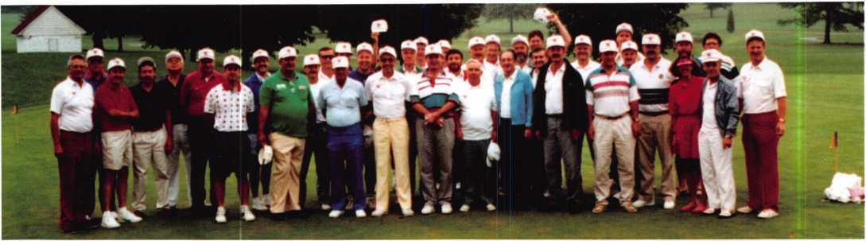

The next stop for the ALOA Open was in Atlanta, GA. Yale spon­sored the tournament at the Bobby Jones Golf Club. It was an excellent facility, with super people and a great golf course. Unfortunately, It rained all day—but the golfers were tough, and everyone made the best of it.

Through the years, the events were sponsored by less than 50 players each year. Sue Moxley and Gail Patterson played a big part in most of these outings. They got sunburned, rained on, and still gave their support by operating beverage carts and tak­ing pictures. They also got some great videos of some of the unique happenings on the golf course.

The next three years (Anaheim, Chicago and Baltimore) were pretty smooth outings and the numbers stayed about the same. However, Yale continued increasing their support each year. In 1993, the ALOA Open went back to Chicago where they booked Cog Hill Country Club, a world-famous course for the Centel Western Open. This was by far the most successful tournament with over 50 players. The committee also picked up some addi­tional support from the industry. Yale continued to be the main sponsor but they were soon joined by Briggs and Stratton (golf balls), Fort Lock Corp. (shirts), Meilink Safe Co. (towels) and U Change Corp. (souvenir coffee cups). This extra support allowed the committee to donate about $7500 to the ALOA Scholarship Fund in 1993.

Aside from a few mishaps, like Chicago 2002 when the bus got lost on its way to the Chalet Hills Golf Course, costing the play­ers an hour of precious game time, the tournaments have been successful beyond belief.

Over the years, certain golf courses have become favorites among the players and organizers. The Legacy in Las Vegas was selected by Golf Digest as one of the top 10 courses in the area. It has beautiful rolling fairways combined with desert canyons and lava outcroppings. Each tee box has cleverly been designed in the shapes of playing card suite: hearts, diamonds, clubs and spades. It remains the number one pick of the committee and players and will be the first-choice location for the ALOA Open in 2006.

Due to the increase in the number of players a Women’s Division and a Handicap Division was created in 1994. The committee also adopted a unique scoring system called “Peoria Scoring” for large groups who don’t have an up-to-date handicap. This system allows everyone to shoot between 69 and 99.

The ALOA Open awards five trophies for this event, two for men, two for women and one combo for the Handicap Division. In addition, all the winners’ names are put on a plaque, which hangs in the ALOA headquarters and travels to all conventions where it is displayed proudly. The plaque was donated by the late Ken Stemig, Sr. who was a dedicated ALOA Open player in the elite group of golfers attending the first 10 tournaments. He even presented all the 10-year people with a Sterling silver money clip commemorating the occasion. Ken won the ALOA Open twice. He was an excellent golfer with a single-digit handicap. Ken passed away in May of 2001. There is now a new plaque that was designed and created by Ken Stemig, Jr., in memory of his father. It’s official name is the “Ken Stemig Sr. Memorial Award.” Five golfers’ names will be added every year for the next 25 years. This plaque represents how much Ken Stemig Sr. loved the ALOA Open Golf Classic and all for which it stands.

Every dollar generated by the ALOA Open goes directly to the Scholarship Foundation. The interest earned off the principle goes to the education of needy students coming into the security profession each year.

Reginald Moxley, John Patterson will continue to support the ALOA Open as Scott Henke, Bill Young, and Vince Forman form the new committee. John Patterson stated, “With the new com­mittee in place, I look for great things in the future. New blood always brings fresh ideas. The new committee is about the same age that Reg and I were when we began the ALOA Open 20 years ago. They will be eager to add to the Scholarship Foundation and will have a great nucleus of past golfers to build upon.” Bill Young happily accepted the new committee position, stating, “We have some pretty big shoes to fill. If we can do half the job these guys did over the years, it will be a big accomplishment.”

Keynotes • October 2005

On the Road  
w i th th e Board

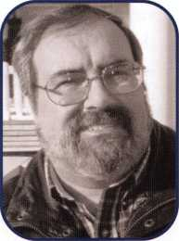

The Central Pennsylvania Locksmith Association held  
a great picnic. Alan Keister did a fine job organiz-  
ing the affair held at Knoeble's Grove Amusement

Resort in Elysburg, PA on August 7, 2005. This was the third year  
I have had the pleasure of attending and I'm ready to go back  
next year!

Dear Members,

Your Directors and I have been out and about meet-  
ing many of our members. It has been a pleasure  
hearing from and speaking with you. Many of us  
have been attending our own local membership  
meetings.

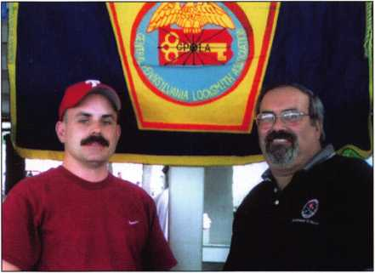

Left to Right: Alan Keister and Bob Mock

I had the honor of swearing in the newly-elected officers of the South  
Jersey Locksmiths' Association in August. Congratulations to the new  
officer. I know they will carry on the tradition of dedication that  
makes South Jersey such a great association.

October's calendar is filling up quickly. On October 8, 2005,1 will  
be Keynote Speaker at the Institutional Locksmiths Association Con-  
vention, Banquet and Trade Show. There I will be teaching, holding  
meetings and host the ALOA booth to meet and greet attendees. Ver-  
non Kelley, CPL, one of your Northeast Directors will also be attend-  
ing these events. Northeast Director, Peter Sarailian, CRL, will be trav-  
elling to Sturbridge, MA to attend the Yankee Convention. Southeast  
Director, Ken Kupferman, CPL is off to ASIS in Orlando, Florida.  
He and Secretary, John Soderland, CML, CMST will be attending  
SERLAC in Orlando.

We want to hear from you. If you have a special event or would like  
one of your Directors to come and speak at your meeting, please  
contact us at our web site ([www.aloa.org](http://www.aloa.org)). If humanly possible and  
barring prior commitments, one of us will be there!

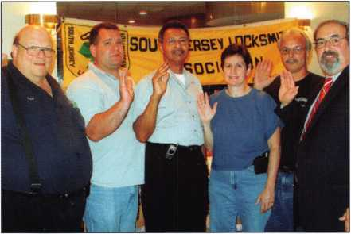

Left to Right: Sergeant at Arms—Paul Palmisano,

Vice President—Joseph Reustle, President—Melvin Weems,  
Secretary—Veronica McCabe, Treasurer—Fred Stunman,  
and Bob Mock.

Kooerr c. /v\ock

Keynotes • October 2005

ALOA Working with NASTF to Benefit Automotive Locksmiths

ALOA has recently withdrawn support of “The Motor Vehicle Owners Right to Repair Act” (HR 2048). It was hoped that this legislation would help locksmiths gain access to vehicle key and immobilizer codes that would ulti­mately benefit the consumer. After supporting the legislative process for nearly three years, and a subsequent lack of movement on this bill, ATOAs directors feel that this goal can now be accomplished through non-legislative means.

ALOA has become a primary participant of the Vehicle Security Committee of the National Automotive Service Task Force and hosted the last two meetings of this com­mittee. The NASTF is a not-for-profit, no-dues task force established to facilitate the identification and correction of gaps in the availability and accessibility of automotive service information, service training, diagnostic tools and equipment, and communications for the benefit of automotive service professionals. NASTF is a voluntary, cooperative effort among the automotive service industry, the equipment and tool industry, and automotive manufacturers.

The topic of vehicle security is a complex issue and ties in with other concerned entities, namely auto insurance and law enforcement. For this reason, NASTF saw the need to create a committee to address this important issue. The committee is made up of representatives from every major auto manufacturer, the Association of International Automobile Manufacturers (AIAM), the Automotive Service Association (ASA), the National Insurance Crime Bureau (NICB), ALOA, independent locksmiths and repair shop owners, and various automobile clubs.

The goal of the Vehicle Security Committee is to create a mechanism for the secure release of data required to gener­ate automotive keys and return the vehicle to drivability for the authorized owner of the vehicle. This mechanism would require a registry of pre-qualified service providers to be maintained by a neutral agency, in this case the NICB would be the likely candidate. The qualifications would consist of, but are not limited to, a criminal background check, indemnity (insurance and bonding), and adherence to a Positive ID policy and record keeping. The Secure Data Release Model (SDRM) is illustrated in figures 1 and 2.

ALOA needs your help and feedback. Please visit the ALOA website ([www.aloa.org/NASTFpoll](http://www.aloa.org/NASTFpoll)) and answer the following questions:

1. Based on the SDRM, would your business be
2. Very Interested
3. Interested
4. Not something that you need
5. How many calls a week do you get for automotive key generating when the keys have been lost?
6. How many of these calls are you unable to service because of inaccessability to the information required to produce a working key?

You can send additional comments to ALOA’s representatives to the committee: Bill Young (Trustee) [youngcml@yahoo.com](mailto:youngcml@yahoo.com) and Ken Kupferman (SE Director) [ken@affordablelock.com](mailto:ken@affordablelock.com). For meeting minutes and committee activity, visit [www.nastf.org](http://www.nastf.org).

Keynotes • October 2005

Secure Data Release Model (SDRM)

**FIGURE 1 : REGISTRATION PROCESS FOR TECHNICIANS**

Automotive Security  
Professionals

-includes locksmiths and  
aftermarket technicians who  
perform security related  
services like lockout and lost  
key replacement-

**Technician registers providing e-mail address and cell phone number**

**NICB performs background check.**

**Provides technician with NICB Identification  
Number & expiration date**

STEP #1:

PRE-REGISTER WITH NICB

**Technician registers with OEM by supplying NICB ID number and e-mail address**

**OEM notifies technician that user account**

**is approved**

STEP #2:

PRE-REGISTER WITH OEMs

STEP #3:

USE OEM EXISTING OEM  
SYSTEM TO ACQUIRE  
INFORMATION NECESSARY  
TO PERFORM SECURITY  
RELATED SERVICES

**FIGURE 2 : USING THE SYSTEM**

NOTE : ACCESS AND RESET INFORMATION WILL NOT BE PROVIDED  
IF EITHER THE VEHICLE IS IDENTIFIED AS BEING STOLEN OR THE  
USER REQUESTING ACCESS CAN NOT BE VERIFIED.

|  |  |  |  |  |  |  |
| --- | --- | --- | --- | --- | --- | --- |
| CONSUMER |  | TECHNICIAN |  | OEM |  | NICB |
| Consumer has a problem | | Technician verifies consumer as | | OEM verifies user | | NICB checks user is in |
| and contacts Technician | | owner of vehicle | | OEM contacts NICB and | | database |
|  | | Technician requests information | | supplies technician0 0 | | NICB checks VIN with |
|  | | from OEM through pre-approved | | NICB ID# and VIN | | stolen car registry |

**account. Technician supplies NICB ID# and VIN to OEM system.**



**Consumer receives replacement keys**

**Technician uses authorization code to access Immobilizer reset or key code information from OEM Web site.**

**OEM notifies technician via cell phone text message with authorization code to use OEM Web site security information**

**NICB notifies OEM the user and vehicle is clear**

**Technician makes new keys and/or fixes customer nroblem**

Keynotes • October 2005



|  |  |
| --- | --- |
| Bylaws Chanc | ] e s |
| Update |  |

One of the Bylaws changes (Article III, Section la: Active Members) that goes into effect on January 1st,

2006 reads:

“Persons who have been actively engaged in the locksmith/access control industry for a minimum of two years, have achieved one of ALOA’s recognized program designations, and can provide at least two of the fol­lowing items...”

This means that all new members of ALOA must join as “Probationary Members” unless they have a recog­nized proficiency designation. This designation may be one of ALOA’s (CML, CPL, CRL or RL) or one from another related organization such as “CPP”, awarded by the American Society of Industrial Security (ASIS). Probationary Members will have three years to achieve a designation or they will not be allowed to continue their membership.

Current ALOA members will have varying lengths of time to achieve a designation depending on the “Grandfathering” schedule that was approved by the membership in a related bylaws change.

Members, whose business address is outside of the United States, are 50 years old or older, or who have been a member for at least 20 years do not ever have to achieve a professional designation.

Members who are 40 - 49 years old or who have been a member for 10-19 years are exempted for five years.

Members who are under 40 years of age or who have been a member for less than 10 years are exempted for three years.

The “clock” starts on January 1st, 2006. At the end of the period of time allowed for the “grandfathering”, members who have not achieved a recognized designation will not be allowed to renew their ALOA Membership.

All of the ALOA PRP designations now require that those holding the designation take approved educational instruction periodically to keep the designation. Therefore members who allow their PRP (or any other) desig­nation to lapse will not be allowed to continue membership. All people holding, or achieving, PRP designation will be informed of the rules for maintaining these designations.

The changes were passed to improve the overall professionalism and qualification of the ALOA members.

Keynotes • October 2005

*ako amiabk:*

Black Fire Engine Red

Pewter Purple Grape

Bright Nickel Construction Orange Brass Plated Cobalt Blue Hot Pink

Prevents Surreptitious Entry at Airports.

Know when your bag has been searched by a TSA agent or violated by an unknown person.

**SearchAlert®**



Recognized by the TSA

Security Window

lock has been opened

o lock not opened

**TRAVEL SENTRY**

CERTIFIED



Security Products

301 West Hintz Road • Wheeling, II 60090 800.733.8588 • Fax: 847.537.1881 • [www.cclsecurity.com](http://www.cclsecurity.com)

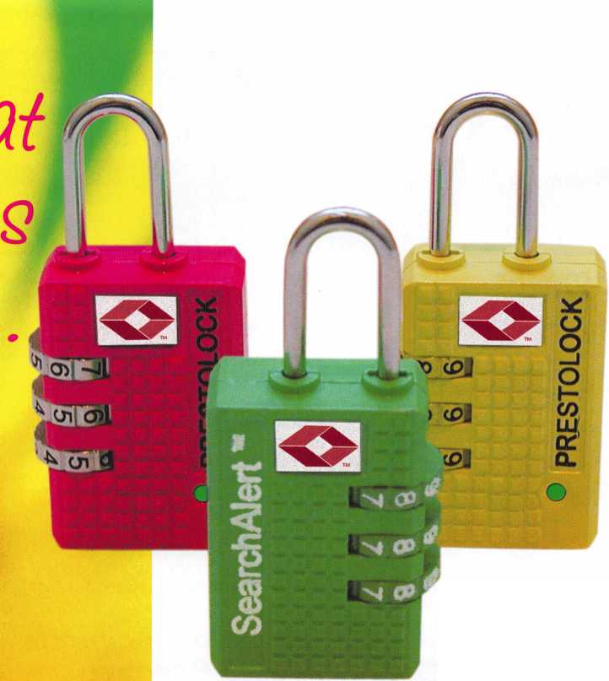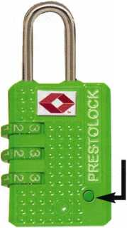

**Classifieds**

EMPLOYMENT

LOCKSMITH WANTED

Immediate opening at one of Columbus Ohio's largest locksmith companies. If you are a lock­smith with three years of commercial experience and want to work 8:30 to 5:00, come join our team! We are a full-service security center. Excellent benefits include 401 K, health insur­ance, paid vacation, sick leave, and continuing education. Contact Bill or Tim at Golden Bear Lock and Safe, Inc. 614-733-5625 fax 614- 733-0004, or email [goldenbearlock@cs.com](mailto:goldenbearlock@cs.com).

LOCKSMITH NEEDED

We are a 40-year-old rapidly growing company in need of experienced locksmiths. We provide all the tools, a brand new van, key machines, uniforms...the works. Salary is dependant upon experience and skill, very competative wage and benefits package. Paid Vacation, 401k, medical, cross training in our electronic security division and much more. We know how to treat good employees well. Please send resume or inquiry to [paulbrandon@lockguys.com](mailto:paulbrandon@lockguys.com) or call 253-839-3443

LOCKSMITH NEEDED

Large Lock shop in the Palm Springs area of California is looking for an experienced lock­smith for field work. Must be proficient in master keying, safety deposit boxes and working knowl­edge of safes. Salary plus commission, health insurance benefits, and 40IK plan. Please fax resume to 760-779-1 811 or call 760-346-5214.

EXPERIENCED SERVICE TECHNICIAN

sought in established company in Central Illinois. Must have good driving record, positive work habits and be neat in appearance. Our compa­ny offers a competitive salary with an excellent benefit package - many EXTRAS. Mail or Fax resume to: Denny at Dave & Harry Locksmiths, Inc. 1 16 E. University Avenue, Champaign, IL 61820. Telephone: 217-352-5034 Fax: 217-352-3505.

PROFESSIONAL EXPERIENCED LOCK­SMITH/SAFE TENICIANS WANTED:

We are in need of 1 to 2 technicians with the ability to sell, install and service all major manu­factures hardware. We are located in Knoxville,

Tennessee and service all areas of east and mid­dle Tennessee. Must have a clean criminal and driving record. Must have a professional attitude and appearance. Background check and refer­ences must be supplied. Must be experienced in commercial, industrial, and residential hard­ware, sales, service, and installations. Access, SAFE, and other areas ARE a plus. Paid holi­days, retirement, health insurance, uniforms, tools and truck supplied. 8 am - PM Monday - Friday. Call:865-522-0841 Fax:865-637-2359 Email:[INFO@FMGEORGE.COM](mailto:INFO@FMGEORGE.COM) 800.484.5577 pin 0841

ACCESS CONTROL TECHNICIAN NEEDED

He/she must have 3-4 years experience in Sales & Installation of Electronic access control & cctv Installation & Service. Contact Denny Birt 1-800- 352-5034

LOCKSMITH WANTED

Busy shop in Woburn Massachusetts seeks expe­rienced locksmiths for Auto, Commercial, Residential, Safe and Card Access work. We have a large AAA area which we cover and do transponder and high security keys. Will help train in fields you are not familiar with. Sub con­tractors welcome or we will supply tools and van. Great opportunity for self-motivated individ­ual. Please sign up to join our team. Call John at 781-933-9999 or send resume to: Locks & Keys, Inc., PO Box 222, Woburn, MA 01801. Thank you for your consideration.

WANTED TO BUY/SELL

CLEANING WAREHOUSE OVERSTOCK MUST GO

Cor-Key knobs for Schlage A/D-line hardware. S&G 6730 like new replaced with digital. Free dial and ring, Van Lock cam locks, pin kit for both cylinders and keys. Large assortment of all

items. Please call for quantities and pricing. Liberty Lock & Safe 702-871-5397 ex. 2233.

SAFE DEPOSIT BOX LOCKS,

PARTS AND MORE

Wholesale prices. Reconditioned and new locks. All manufacturers; Diebold, Herring Hall & Marvin, llco, Lefebure, Mosler, S&G, Security Corp & Precision. Also available new replace­ment locks. We have a large stock of parts - doors, bond boxes, hinges, key blanks, full sec­tions and more. Call WBI (954) 484-2404

LOCKSMITH EQUIPMENT AND INVENTORY FOR SALE

Key Machines, key blanks, Inventory - prefer to sell complete, will consider offers on individual pieces. Call M.A. Box 432-448-2832 or 448-634-4808.

FOR SALE

Locksmith Equipment and Inventory: Key Machines, key blanks, inventory - prefer to sell complete, will consider offers on individual pieces. Call M.A. Box 432-448-2832 or 448-634-4808.

BUSINESS FOR SALE

16 year old locksmith business located in Miami, FL. Large commercial account base. Serious inquires only. $375,000.

305 233-4447

BUSINESS FOR SALE

Central Florida Locksmith Business with two fully equipped vans, full inventory, tools, key and code machines, etc. Established customer base since 1983. Leased storefront shop. Gross sales 250K-300K. Priced to sell at 150K. Contact Howard at 407-933-0722.

LOOKING FOR BOOK

I am looking for The Comprehensive Manual of Locksmithing by Shankle and Shankle. Please contact Earl Karsikas at 651-769-2579 or by mail at 8257 Hyde Ave, Cottage Grove, MN 55016.

Classified Advertising Policy

Classified advertising space is provided free of charge to ALOA members and for a fee of $2.00 per word, $40.00 minimum for non members. Classified ads may be used to advertise used merchandise and overstocked items for sale, "wanted to buy" items, business opportunities, employment opportunities/positions wanted and the like. Members or non members wishing to advertise services or new mer­chandise for sale may purchase a "Commercial Classified Ad" for a fee of $4.00 per word with a minimum of $100.00. Each ad will run for two issues. For blind boxes there is a $10.00 charge for members and non members. All ads must be submitted in writing to the Advertising Sales Department via fax at 817-645-7599 or through an email to [adsales@aloa.org](mailto:adsales@aloa.org) by the fifteenth of the month two months prior to issue date. ALOA reserves the right to refuse any classified advertisement that it deems inappropriate according to the stated purpose of the classified advertising section.

**NOW EDGE™ KEY CONTROL KEEPS YOUR CUSTOMERS COMING BACK.**

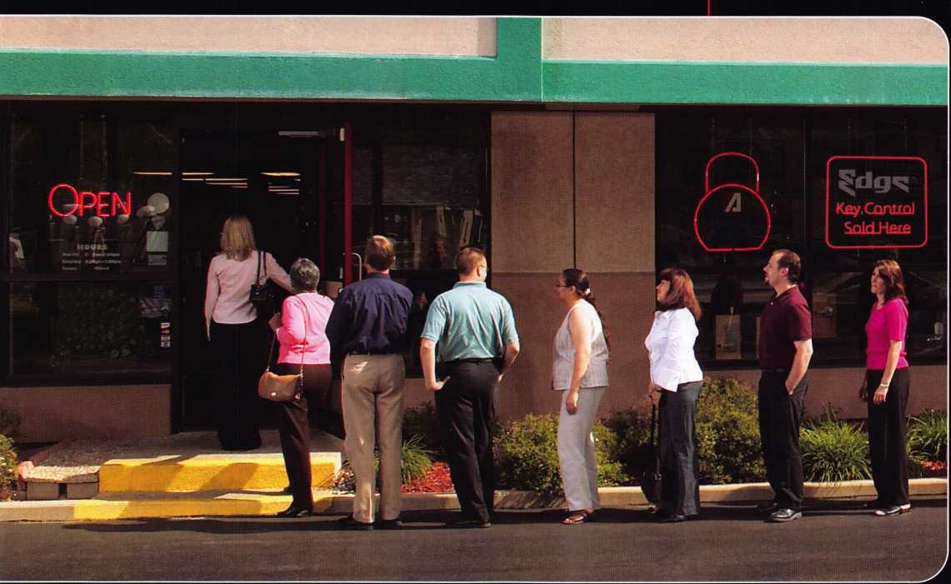

***Introducing Edge™ key control:  
the patent-pending system that***

***brings customers back to you — only you —  
again and again.***

What a great way to gain new customers and lock-in business for years to come!

Unlike costly "high security" systems, Edge lets you offer the kind of security a multitude of businesses need for door locks, padlocks — the works.

No one can duplicate keys without their consent. And no one can duplicate keys for them but you!

**Repeat business you can “own.”**

Edge key control prospects are everywhere — local

restaurants, strip malls, utilities,  
hospitals, municipalities, neigh-  
borhood stores, franchisees ...  
the list goes on.

Edge lets you deliver the

key-control security

they want — and  
can pay for. Year

after year after year.

Ask your distributor about  
Edge key control today.

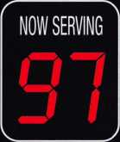

*Edge fits American Lock® and Master Lock® commercial security products, as well as other makes.*



© 2005 American Lock Company, a Division of Master Lock Company

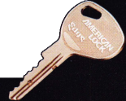

Distributor

**1 st In Hardware, Inc.**

Phone: 866-397-9900 Fax: 866-646-0045 www. 1 stinhardware.com

**Accredited Lock Supply Co.**

Phone: 800-652-2835 Fax: 201-865-0030 [www.acclock.com](http://www.acclock.com)

**Andrews Wholesale Lock Supply**

Phone: 717-272-7422 Fax: 717-274-8659 [www.andrewslock.com](http://www.andrewslock.com)

**Boyle & Chase Inc.**

Phone: 800-325-2530 Fax: 800-205-3500 [www.boyleandchase.com](http://www.boyleandchase.com)

**Clark Security Products**

Phone: 888-784-1311 Fax: 619-718-7333 [www.clarksecurity.com](http://www.clarksecurity.com)

**Cook's Building Specialties**

Phone: 505-883-5701 Fax: 505-883-5704

**Dire's Lock & Key Company**

Phone: 303-294-0176 Fax: 303-294-0198

**Direct Security Supply, Inc.**

Phone: 800-252-5757 Fax: 800-452-8600

**Discount Key Machines.Com/Busch**

Phone: 800-332-8724 Fax: 407-363-4666

**Doyle Security Products**

Phone: 800-333-6953 Fax: 612-521-0166 [www.doylesecurity.com](http://www.doylesecurity.com)

**Dugmore and Duncan, Inc.**

Phone: 888-384-6673 Fax: 888-329-3846

**Ewert Wholesale Hardware**

Phone: 800-451-0200 Fax: 708-597-0881

**Foley-Belsaw Company**

Phone: 800-821-3452 Fax: 816-483-5010 [www.foley-belsaw.com](http://www.foley-belsaw.com)

**Fried Brothers Inc.**

Phone: 800-523-2924 Fax: 215-592-1255 [www.fbisecurity.com](http://www.fbisecurity.com)

**Hans Johnsen Company**

Phone: 214-879-1550 Fax: 214-879-1530

**Hardware Agencies, Ltd.**

Phone: 416-462-1921 [www.hardwareagencies.com](http://www.hardwareagencies.com)

**IDN Incorporated**

Phone: 817-421-5470 Fax: 817-421-5468 [www.idn-inc.com](http://www.idn-inc.com)

**Instant Hardware Delivery, Inc**

Phone: 800-355-1107 Fax: 800-663-8518

**Intermountain Lock & Supply**

Phone: 800-453-5386 Fax: 801-485-7205 [www.intermountainlock.com](http://www.intermountainlock.com)

**International Electronics, Inc**

Phone: 800-343-9502 Fax: 617-821-4443

**Lockmasters, Inc.**

Phone: 859-885-6041 Fax: 859-885-7093 [www.lockmasters.com](http://www.lockmasters.com)

**Locks Company**

Phone: 800-288-0801 Fax: 305-949-3619

**Locksmith Ledger International**

Phone: 770-886-0800 Fax: 770-889-7703 [www.lledger.com](http://www.lledger.com)

**McDonald Dash Locksmith Supply**

Phone: 800-238-7541 Fax: 901-366-0005 [www.mcdonalddash.com](http://www.mcdonalddash.com)

**Monaco Lock Co.**

Phone: 800-526-6094 Fax: 800-845-5625 [www.monacolock.com](http://www.monacolock.com)

**Omaha Wholesale Hardware**

Phone: 800-238-4566 Fax: 402-444-1664 [www.omahawh.com](http://www.omahawh.com)

**RA-Lock Company**

Phone: 972-775-6301 Fax: 972-775-6316 [www.ralock.com](http://www.ralock.com)

**Security Distributors Inc**

Phone: 800-333-6953 Fax: 612-524-0166

**Security House**

Phone: 905-669-5300 Fax: 905-660-6313 [www.securityhouselock.com](http://www.securityhouselock.com)

**Security Lock Distributors**

Phone: 800-847-5625

Fax: 800-878-6400

[www.securitylockdistributors.com](http://www.securitylockdistributors.com)

**Southern Lock and Supply Co.**

Phone: 727-541-5536 Fax: 727-544-8278 [www.southernlock.com](http://www.southernlock.com)

**Stone & Berg Wholesale**

Phone: 800-225-7405 Fax: 800-535-5625

**The Locksmith Store Inc.**

Phone: 847-364-51 1 1 Fax: 847-364-5125 [www.locksmithstore.com](http://www.locksmithstore.com)

**Timemaster Inc.**

Phone: 859-259-1878 Fax: 859-255-0298 [www.time-master.com](http://www.time-master.com)

**Top Notch Distributors, Inc.**

Phone: 800-233-4210 Fax: 800-854-4146 [www.topnotch.bz](http://www.topnotch.bz)

**Turn 10 Wholesale**

Phone: 800-848-9790 Fax: 800-391-4553

**U.S. Lock Corp.**

Phone: 800-925-5000 Fax: 800-338-5625 [www.uslock.com](http://www.uslock.com)

**Wilson Safe Company**

Phone: 215-492-7100 Fax: 215-492-7104 [www.wilsonsafe.com](http://www.wilsonsafe.com)

Manufacturer

**A & B Safe Corporation**

Phone: 800-253-1267 Fax: 856-863-1208 [www.a-bsafecorp.com](http://www.a-bsafecorp.com)

**ABUS Lock Company**

Phone: 800-352-2287 Fax: 602-516-9934 [www.abus.com](http://www.abus.com)

**Access Security Products Ltd.**

Phone: 905-337-7874 Fax: 905-337-7873 [www.access-safe.com](http://www.access-safe.com)

**Adams Rite Mfg Company**

Phone: 800-872-3267 Fax: 800-232-7329 [www.adamsrite.com](http://www.adamsrite.com)

**Adesco Safe Mfg. Company**

Phone: 800-694-9340 Fax: 562-408-6427 [www.adesco.com](http://www.adesco.com)

**Adrian Steel Company**

Phone: 800-677-2726 Fax: 517-265-5834 [www.adriansteel.com](http://www.adriansteel.com)

**Advanced Diagnostics USA Inc**

Phone: 650-876-2020 Fax: 650-876-2022 [www.ad-mvp.com](http://www.ad-mvp.com)

**All Five Tool Company, Inc.**

Phone: 860-583-1691 Fax: 860-583-4516 [www.all5tool.com](http://www.all5tool.com)

**American Security Products**

Phone: 909-685-9680X1083 Fax: 909-685-9685 [www.amsecusa.com](http://www.amsecusa.com)

**Bianchi USA, Inc.**

Phone: 800-891-2118 Fax: 216-803-0202

**Buddy Products**

Phone: 800-886-8688 Fax: 312-733-8356 [www.buddyproducts.com](http://www.buddyproducts.com)

**CCL Security Products**

Phone: 800-733-8588 Fax: 847-537-1800

**COMPX Security Products**

Phone: 864-297-6655 Fax: 864-297-9987 [www.compxnet.com](http://www.compxnet.com)

**D&D Technologies (USA), Inc.**

Phone: 714-677-1300X292 Fax: 714-677-1299 [www.ddtechusa.com](http://www.ddtechusa.com)

**DETEX Corp.**

Phone: 800-729-3839 Fax: 830-620-6711 [www.detex.com](http://www.detex.com)

**Don-Jo Manufacturing, Inc.**

Phone: 978-422-3213 Fax: 978-422-3467 [www.don-jo.com](http://www.don-jo.com)

**Door Controls International**

Phone: 800-742-3634 Fax: 800-742-0410 [www.doorcontrols.com](http://www.doorcontrols.com)

**FireKing Security Products**

Phone: 800-457-2424 Fax: 800-896-6606 [www.fkisecuritygroup.com](http://www.fkisecuritygroup.com)



Keynotes • October 2005

associate

members

**Framon Manufacturing Company Inc.**

Phone: 989-354-5623 Fax: 989-354-4238 [www.framon.com](http://www.framon.com)

**HY-KO Products Co.**

Phone: 330-467-7446 Fax: 330-467-7442

**Hammerhead Industries/ Inc.**

Phone: 805-658-9922 Fax: 805-658-8833 [www.gearkeeper.com](http://www.gearkeeper.com)

**Ingersoll Rand SSA**

Phone: 317-613-8025 Fax: 317-613-8068 [www.schlagelock.com](http://www.schlagelock.com)

**Jackson Corporation**

Phone: 323-269-81 1 1 Fax: 800-888-6855 [www.jacksonexit.com](http://www.jacksonexit.com)

**Jet Hardware Mfg., Co.**

Phone: 71 8-257-9600 Fax: 718-257-0973 [www.jetkeys.com](http://www.jetkeys.com)

**KABA ILCO Corp.**

Phone: 252-446-3321 Fax: 252-446-4702 [www.kaba-ilco.com](http://www.kaba-ilco.com)

**KEY-BAK/West Coast Chain Mfg.**

Phone: 909-923-7800 Fax: 909-923-0024 [www.keybak.com](http://www.keybak.com)

**Keri Systems Inc.**

Phone: 408-451-2520 Fax: 408-441-0309 [www.kerisys.com](http://www.kerisys.com)

**Knaack Manufacturing Co.**

Phone: 800-456-7865 Fax: 815-459-9097 [www.weatherguard.com](http://www.weatherguard.com)

**LAB Security**

Phone: 800-243-8242 Fax: 860-583-7838 [www.labpins.com](http://www.labpins.com)

**La Gard Inc.**

Phone: 310-325-5670 Fax: 310-325-5615 [www.lagard.com](http://www.lagard.com)

**Lock America/ Inc. dba L.A.I. Group**

Phone: 714-373-2993 Fax: 714-373-2998 [www.laigroup.com](http://www.laigroup.com)

**Lucky Line Products, Inc.**

Phone: 858-549-6699 Fax: 858-549-3241 [www.luckyline.com](http://www.luckyline.com)

**M.A.G. Manufacturing**

Phone: 714-891-5100 Fax: 714-892-6845 [www.magmanufacturing.com](http://www.magmanufacturing.com)

**MUL-T-LOCK USA, Inc.**

Phone: 800-562-351 1 Fax: 973-778-4007 [www.mul-t-lock.com](http://www.mul-t-lock.com)

**Major Mfg, Inc.**

Phone: 714-772-5202 Fax: 714-772-2302 [www.majormfg.com](http://www.majormfg.com)

**Maxcess Card Systems Ltd**

Phone: 949-492-5964 Fax: 949-492-0415 www. maxcess-card .com

**Medeco Security Locks**

Phone: 540-380-5000 Fax: 540-380-5010 [www.medeco.com](http://www.medeco.com)

**Mil-Comm Products Co Inc**

Phone: 201-935-8561 Fax: 201-935-6059

**ROFU International Corp.**

Phone: 253-922-1828 Fax: 253-922-1728 [www.rofu.com](http://www.rofu.com)

**Rutherford Controls Int'l Co.**

Phone: 757-427-1230 Fax: 757-427-9549 [www.rutherfordcontrols.com](http://www.rutherfordcontrols.com)

**STRATTEC Security Corp.**

Phone: 414-247-3415 Fax: 414-247-3692 [www.strattec.com](http://www.strattec.com)

**Sargent & Greenleaf, Inc.**

Phone: 800-826-7652X201 Fax: 859-885-3063

[www.sargentandgreenleaf.com](http://www.sargentandgreenleaf.com)

**Sargent Manufacturing Co.**

Phone: 800-727-5477 Fax: 888-863-5054 [www.sargentlock.com](http://www.sargentlock.com)

**Schwab Corp.**

Phone: 765-447-9470 Fax: 765-447-8278 [www.schwabcorp.com](http://www.schwabcorp.com)

**Securifort Inc**

Phone: 819-359-2226 Fax: 819-359-2218 [www.securifort.com](http://www.securifort.com)

**Securitron Magnalock Corp.**

Phone: 775-355-5625 Fax: 775-355-5636 [www.securitron.com](http://www.securitron.com)

**Security Door Controls**

Phone: 805-494-0622 Fax: 805-494-8861 [www.sdcsecurity.com](http://www.sdcsecurity.com)

**Security Solutions**

Phone: 405-376-1600 Fax: 405-376-6870 [www.securitysolutions-usa.com](http://www.securitysolutions-usa.com)

**Townsteel, Inc.**

Phone: 626-858-5080 Fax: 626-858-3393 [www.townsteel.com](http://www.townsteel.com)

**UCA Inc**

Phone: 972-312-0599X12 Fax: 972-692-7056

[www.ibuttonlock.com](http://www.ibuttonlock.com)

**Ultra Lift Corporation**

Phone: 800-346-3057 Fax: 408-297-1199 [www.ultralift.com](http://www.ultralift.com)

**Videx Inc.**

Phone: 541-758-0521 Fax: 541-752-5285 [www.videx.com](http://www.videx.com)

**ASSA Abloy Americas**

Phone: 800-438-1951 Fax: 800-338-0965

Service

Organization

**Allstate Insurance Company**

Phone: 800-859-0247 Fax: 847-326-7509 [www.allstate.com](http://www.allstate.com)

**Cross Country Automotive Services**

Phone: 800-541-2262 Fax: 781-393-0256 [www.argosi.com](http://www.argosi.com)

**Massglass & Door Service**

Phone: 888-742-8837 Fax: 805-497-2255 [www.massglass.com](http://www.massglass.com)

**Webster Safe & Lock Co., Inc.**

Phone: 901-332-2911 Fax: 901-332-2878 [www.webstersinc.com](http://www.webstersinc.com)



Keynotes • October 2005



Senate Readies for Legislative Battle on Association Health Plans (AHP)

Since Congress returned from its August recess in early September, its focus has been almost exclu­sively on the truly monumental task of responding to the devastation of the Gulf Coast region by Hurricane Katrina. While the need to deal with the Katrina response and the Supreme Court nomina­tions will continue to dominate the Senate's schedule in the coming weeks, there is nevertheless signifi­cant behind-the-scenes activity in the Senate on Association Health Plans (AHP). It is clear that the most serious effort to date will be made this fall to have the Senate approve legislation that contains the core components of the Small Business Health Fairness Act (S. 406).

The AHP bill did gain a new backer in early September when Senator Sam Brownback (R-KS) official-  
ly became a cosponsor of the bill. Senator Mike Enzi (R-WY) continues working on development of a  
comprehensive health insurance reform bill that he has indicated will include provisions for  
Association Health Plans. It is critical to retain the core components of S. 406, including the option  
of self-funding for AHPs, in Enzi's bill. It appears that Senator Enzi will circulate a draft in the next  
few weeks and then attempt to have the legislation approved by the Senate Health, Education,

Labor and Pensions Committee. As soon as further information regarding the status of Senator  
Enzi's proposal becomes available, members will be briefed accordingly.

Meanwhile, Senators Olympia Snowe (R-ME) and Jim Talent (R-MO) have been holding  
meetings with numerous Senate colleagues in order to obtain more support for S. 406  
and d iscuss potential changes to the bill that might enable it to move forward in some  
form. One of the most encouraging indications that the Senate is serious about acting  
on AHP legislation is that Senate Majority Leader Bill Frist (R-TN) is actively monitor-  
ing the discussions on AHPs among Senators. According to sources, Senator Frist is  
eager to fulfill his commitment to Senator Talent to get an AHP bill through the  
Senate this year.

Should a mark-up of Senator Enzi's health  
reform legislation be scheduled, it will be impor-  
tant for all ALOA members to contact members  
of the Senate Health, Education, Labor and  
Pensions Committee with respect to Enzi's bill.



As one of the directors of your association, I understand that some members would like to know more about what happens in ALOA. Everyone knows that we have a convention once a year with great classes, a great trade show, and camaraderie among attendees that lasts all year. Unfortunately, not much else is known about what happens the rest of the year unless you are on the internet in our chat rooms, or you read the presidential viewpoint in Keynotes.

During the week of August 16th through the 1 8th, I was asked to help represent our organization at the "National Conference of State Legislatures" in Seattle, Washington.

As legislation is a top priority for ALOA, this turned out to be an excellent venue for ALOA to  
make state Senators and Representatives understand that locksmiths are not licensed in 46 of our  
50 states. Most people we talked with could not believe this was the situation. Most believed that  
locksmiths were already licensed, insured and bonded and that background checks were done.  
These legislators were astonished to learn that this is not the case. We heard quite a few stories of  
how locksmiths were recently used by the people we talked with, and they just assumed that the  
locksmith was licensed.

Now we need your help. If you are interested in locksmithing licensing for your state, contact  
Tim McMullen, Legislative Manager for ALOA and we will work with you to contact your

legislation. Tim can be reached at 800-532-ALOA(2562) X 300.

Don't let ALOA's time in Seattle be a waste.

Ken Kupferman, CPL

ALOA Southeast Director

Keynotes • October 2005

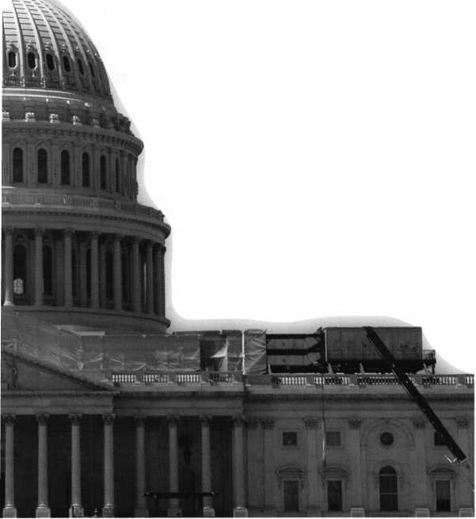

keynotes

IQ i iyit p

J fgyyggf i **’ .** !§%, ^wgaiil

YOUR

**NAME HERE**1-800-355-6322

CALL C 1-800-355-6322 For More / , Information '

^VDERl>^

Professional Business Products

We offer lower prices on standard and custom  
invoices/work orders, checks, business cards,  
repair tags, key tags, magnets and much more.  
Call today for our brochure and samples.

[www.pbp2000.com](http://www.pbp2000.com)

**ADVERTISE WITH  
OUR**

**WEATHERPROOF**

**LABLES**

Marketplace



New! Keedex Stainless Steel Armored Door Loops

ALL

STAINLESS STEEL

DESIGN

STAINLESS

STEEL CONDUIT

STAINLESS STEEL  
END PIECES

STEEL

SCREWS

AVAILABLE FROM YOUR KEEDEX DISTRIBUTOR

MADE IN U.S.A.

COSTS NO MORE  
THAN MOST DOOR  
LOOPS THAT HAVE  
PLASTIC END PIECES

Call or write today  
for yourfree catalog!

Keedex, Inc.

12931 Shackelford Lane  
Garden Grove, CA 92841  
714-636-5657 • Fax: 714-636-5680  
e-mail: [info@keedex.com](mailto:info@keedex.com)

[www.keedex.com](http://www.keedex.com)

|  |  |
| --- | --- |
|  | FROM A & B |
| SAFE CORP. |
| Ik | A & B Chest |
|  | Model WS-0 |
|  | Equipped with dual key, |
| tfgKT | combination or |
|  | electronic locking |
|  | slot optional |
| A & B SAFE CORPORATION | |
| 171 S. Del sea Dr. | |
| Giassboro, NJ 08028-6237 | |
| 856-863-1186 | Fax 856-863-1208 |

Accept Credit Cards!

In your Locksmithing Business,  
Storefronts/Offices/Homebased

Businesses

**No application fees**

**No Monthly Minimum**

**No Lease Requirements**

**0nsite wireless terminals available**

RETRIEVER PAYMENT

SYSTEMS

888-549-6424

IN-STOCK...MORE SAFES

***FREE Freight Program***

***(30 States)***

AMSEC FireKing

Gardall **hayman**

MEIUNK y/CTOR

**TURD** 1**©**

**WHOLESALE SERVICE**

800**-**848-9790



Keynotes • October 2005

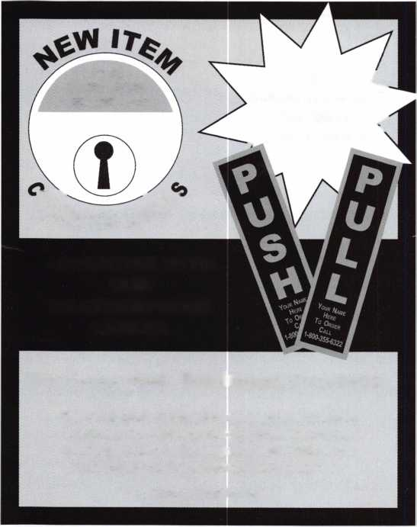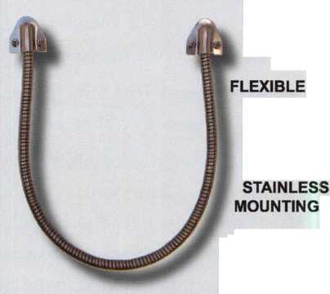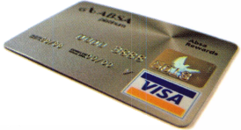

Lockcraft Sms Mewl

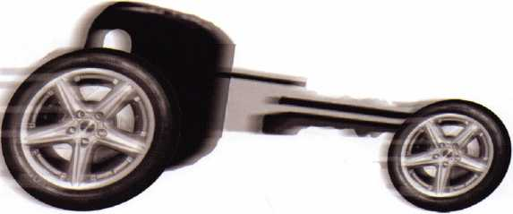

Get used to our market momentum! Lockcraft keeps your sales moving with our ever- expanding lineup of automotive locks, keys and service tools. Ask for all the OEM quality replacements you need ~ for Ford, Daimler- Chrysler, Nissan, Honda, Toyota, and more. Yes, Lockcraft is still priced tight and right. Yes, Lockcraft still boasts 5-day/90% order fill. Yes, Lockcraft still offers the best profit opportunities in the business for you.

Surge ahead with Lockcraft!

E) LOCKCRAFT

2345 N. Central Avenue Brownsville, TX 78521 Phone: 965-838-2480 FAX 956-838-1796

*Repair Sagging Doors in Seconds!*

Fixes Bent & Worn Hinges Instantly!

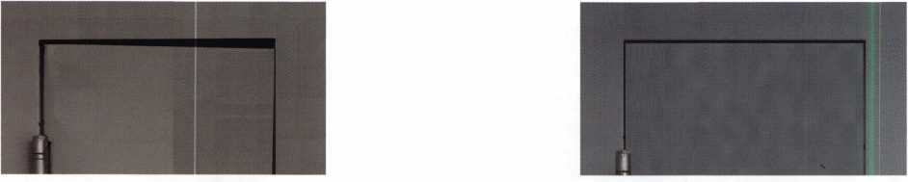

Note Door Hitting Frame

j

i

§

*BEFORE*

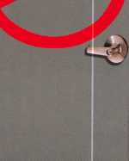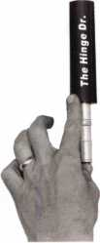

From this to this

Door is Fixed!!

i

***AFTER***

‘S

2>e

inseconds.

[www.hingedoctor.com](http://www.hingedoctor.com)

*No more backaches*

*from pulling & rehanging doors!*

***TheHingeDdsHereH!***

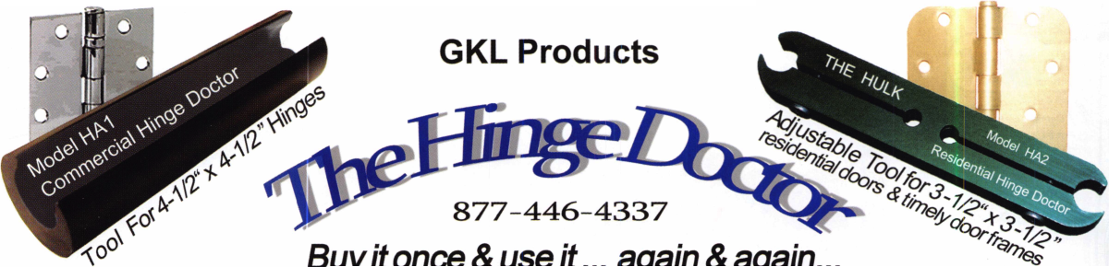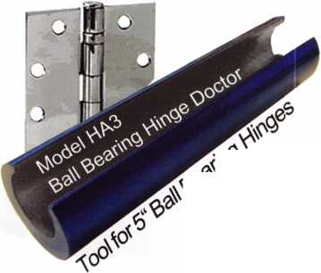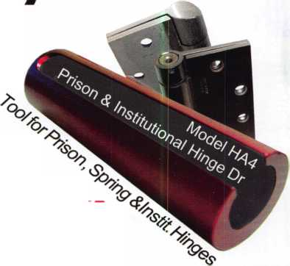

Alberto, 11 years Machine Operator

ECURITY PRODUCTS

Raymond, 4 years Accounting k

Shirley, 23 year Lock Assembly

jars

Service

We represent the 500 employees of CompX Security Products.

Hardworking. Reliable. Dedicated.

And it shows in the products we make.

Is it any surprise that, year after year, you the locksmith community, choose to partner with us?

Made in America does matter to you, and it matters to us. Through our four US facilities, we will continue to provide you with the high quality products you have come to expect from CompX Security Products.

*Cbm*®C

NATIONAL



FORT



TIMBERLINE

*CbmjK*

CHICAGO



iUKsiAas

f NGS XL CAN

f Locksmith 8008LXLC

NGS XL CAN Locksmith Kit 8008LXLC

* NGS XL Tester and Locksmith VIM
* NGS XL CAN VIM

j - vr;Tj*vy:■'■ - I

* 1996-Current Model Year Ford Transponder

PATS Reprogramming Software

* FREE - 2 Additional Years of Software
* 81204 - CAN Vehicle Interface Cable
* 81205 - CAN Power Cable
* 800N - OBDII/EEC-V Cable
* HI 05-00100 - Central Security Module Cable
* NGS/Locksmith/PATS Instruction Manual
* Key Blank/System Quick Reference Card
* Transponder Marketing Support Pack
* Blo-molded Carrying Case

8008LXLC

CAN VIM

81201L

13 Month Warranty

NGS CAN VIM Kit 81201L

* NGS CAN Vehicle Interface Module (VIM)

**•81204-CAN** Vehicle Ir

* 81205 - CAN Auxiliary
* 2003-2005 CAN Soft*
* 2005 Non-CAN Softwa
* Operator's Manual
* Key Blank Quick Refi

81201L

ice Chart

**Mazda Transpo**

**Your key**

**The most reliable unit available for transponder key programming and PATS system diagnostics on ALL Ford Lincoln/Mercury and Mazda* vehicles.**

**CAN Vehicle Interface ModulefanoigT Model Software Update now**

HICI<PK

%sa

